CASTLEN ELEMENTARY SCHOOL
Second Grade School Supply List
2020-2021
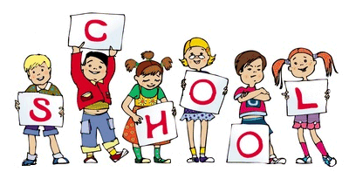
Central Office is requesting that parents provide a face mask for their child to have with them at school each day. Cloth is preferred due to durability.
1-pencil case/box
1-12 pack of colored pencils
1-pack of 24 count crayons
1-pair of scissors
2-packs of #2 pencils (not mechanical)
4-folders with metal clasps
3-spiral notebooks
1-pack of highlighter markers
1-package of Expo markers
2-packs of lined paper
2-Magic Erasers (to use on dry erase boards)

WISH LIST
2- bottles of Germ-X
2- packages of paper towels
2- boxes of tissue
2-packages of Lysol Wipes

