 | ENGLISH* | MATH* | SCIENCE* | SOCIAL STUDIES* | PATHWAY REQUIREMENTS | ACADEMY EXPERIENCES
9TH GRADE | English 9 | Algebra I | Biology | World History | Foundations of Leadership  Career Preparedness  Health  PE | Kuder Portfolio  Guest Speakers  Public Speaking Activities  Assignment of Post-secondary Mentor  Field trips/Tours  Field Experience(s)  Senior Project  Cooperative Education
10TH GRADE | English 10 | Geometry | Physical Science | U.S. History to 1877 | Spanish or French 1
11TH GRADE | English 11 | Algebra II | Zoology | U.S. History 1877 to Present | Spanish or French 2
12TH GRADE | English 12 | Algebraic Connections | Environmental Science | American Government/  Economics | Spanish or French 3
Assessments  &  Credentials | Kuder, ACT ASPIRE, SAT/ACT, ACT Work-Keys |  |  |  | Recommended Electives  Senior Project
Post  Secondary  Goals  and  Planning | Diploma requirements per institution of higher learning  (See your school’s Guidance Counselor) |  |  |  | School and Community Involvement | Attend/Participate in Career Fair(s)  Participate in Various Community Service Activities
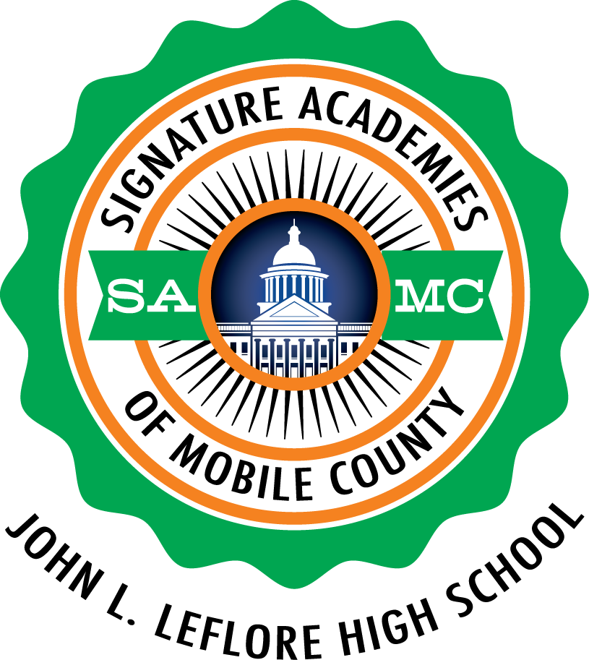
*Refer to the Educational Planning Guide.
LEFLORE MAGNET HIGH SCHOOL
Arts Academy
World Languages Pathway

