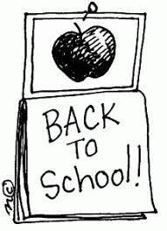
Welcome to 11th Grade Literature
Teacher: Ginger Smith
__________________________

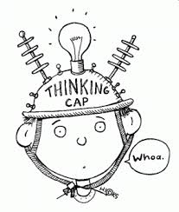
Goals: The goal of this class is to get you ready for the EOC and eventually college, tech school or the working world. Being literate is one of the major skills that the work world prizes and it’s one of the skills that will make you an attractive job candidate.
- To write essays on any topic using an organized method.
- To write excellent narratives anytime and anyplace.
- To know the kinds of research/writing that will help you succeed in college.
- To make you more excellent readers.
- To show so much growth on the EOC that no one will believe it!
___________________________________
Teacher Expectations:
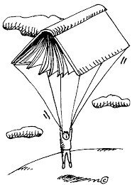
- That you will focus on class. This is not the time for off task talking or playing—save that for later.
- You will not disrupt class learning. We have a new curriculum and format for class that takes a lot of concentration. Repeatedly interrupting the learning process will result in a write up.
- We are all here to help each other. Making fun of people/bullying is not allowed in any fashion.
- I expect you to have a good attitude about 90% of the time. You’d be surprised what you can do just by TRYING. Those successful people you want to be like…they are not successful because they are lucky, they are successful because they TRY and WORK HARD.
- We won’t do everything right the first time, but we will have a fun time learning from our mistakes and getting better and better.
- Cell phones must be put away when you are in class. I should not see your phone on your desk or in your hand. I do not have my phone out in class and you shouldn’t either. This is not only MY rule, but a TCS rule.
- Earbuds should ONLY be used when the teacher says. I do not want to see them hanging around your ears or your neck. Leave the big headphones at home. This is not just my rule, it’s a TCS rule.
- I can take your phone if you have it out, so do us both the professional courtesy of keeping it hidden away.
Behavior Policy:
- No talking when the teachers are talking.
- Treat others with respect and courtesy. Be polite. Help others in our room when you are able.
- Use time wisely. No playing. There is no time for off task behavior. If you have extra time, you should read a book!
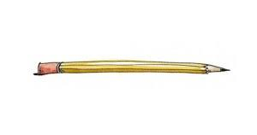
___________________________________

Supplies:
- Pens (blue or black ink)
- Pencils
- Paper and Notebook (preferably one with a few sections.)
- Highlighters
________________
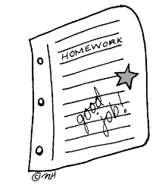
Grading:
40% Writing projects and tests (Writescore benchmark or teacher made.)
25% homework and classwork
15% quizzes and participation

_________________
Topics: We have a totally new curriculum this year so it will be a learning experience for all of us.
- We will still be doing Writescore/Readscore to help us get ready for the EOC. It worked very well last year!!
- We will study speeches, stories, poems and other nonfiction pieces. We will practice some new reading strategies to give us tools for our toolbox.
- Instead of covering LOTS of material, we will be covering a smaller amount, but in ways that take you more deeply into things like author’s purpose, tone, diction, etc…all those nifty little things that you see on the EOC!
- One of the topics we will be looking at is freedom. What does it mean to be free?

Extra Help Policy:
I am always here to help you before or after school and at lunch if you need extra help. I consider that a teacher’s job.
BUT if you goof off all year then want me to give you extra credit in December, you may end up disappointed. Don’t wait too late.

