READING/PHONICS | GRAMMAR/WRITING | MATH | SCIENCE/SOCIAL STUDIES
- Author’s Purpose  - Summarize  - Abbreviations | - Quotation Marks  - Multiple Meaning Words  - Personal Narrative | - Measurement  - Geometry  - Multiplication Facts | - Weather  - Scientists, Artists, & Inventors  - Families & Trade
Mrs. Sharpe’s Class •Keisha.Sharpe@acboe.net
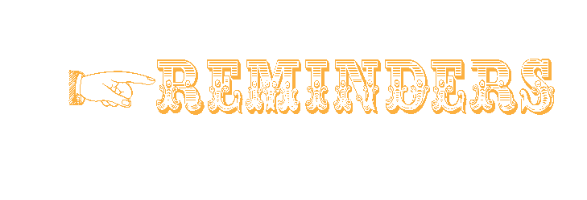

Mr. Jan,
Dr. Oct.
Mrs. Feb.
Ms. Nov.
St. Aug.
Rd. Dec.

Red, White, & Blue Spelling Words
Selection Vocabulary
America birthday flag
freedom nicknames stars
stripes

- 5.6: Weekly Reading & Grammar Test
- 5.7: Weekly Spelling & Vocabulary Test
- 5.3-5.13: DIBELS 8 Testing
- 5.24: Field Day (Students Only)
- 5.28: Awards Day (Grade 2)

We Are Stronger Together!

Look at what we are learning!

If your child is a car rider in the mornings, be sure to get him/her to school before 7:45 to ensure he/she has time to eat breakfast before 8:00. Please send a bottle of water to school with your child daily. Also, allow your child to read for at least 20 minutes each night.
Our school website is: pinelevelelem.com

Ladies & Gentlemen!
May 3, 2021

