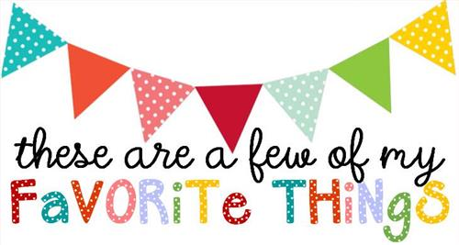

Name: Ashley Rogers
T-shirt Size: Medium
Birthday: July 9th
Monogram: aRn
Favorite Color: glitter
Favorite Flower: daisy
Favorite Scent: anything Fall scented: pumpkin, cinnamon, apple, etc.
Favorite Candy: anything chocolate
Favorite Drink: Sprite or Dr. Pepper
Favorite Food: pizza or Chinese food
Favorite Snack: chips
Favorite Fruit: strawberries
Favorite Restaurant: Olive Garden, Texas De Brazil, Outback, and Pyro’s
Favorite Places to Shop: Amazon
Things I collect: Mississippi Pottery
Favorite Author/Book Series for my own personal reading: Mystery/thriller novels
Wish List for Classroom: Bright color copy paper, expo markers, chair socks, binder rings, amazon cards to buy school supplies.

