COVID-19 Pandemic Propaganda Activity
During WWI and WWII, we talked about the impact of Propaganda on the Homefront and how it was targeted to certain groups and had an intended purpose. So, let's put a different spin on it! There has been some talk of starting up victory gardens, rationing food, and social distancing (staying away from people and avoiding contact) due to the Covid-19 Pandemic.
Use your knowledge of propaganda, the current situation, and your creativity to create a propaganda about the current situation. Remember who your audience is, what your message is, and what you want them to feel. You can create a digital poster or you can draw it on paper and take picture and send by email or remind. It can be about anything from hoarding toilet paper to avoiding people. Have fun with this! " In a paragraph on back: 1) discuss the theme, 2) identify target audience (to whom are you trying to appeal?), and 3) describe the intended meaning

Here are some examples of WWII Propaganda: Its target group in this particular WWII Propaganda was women!

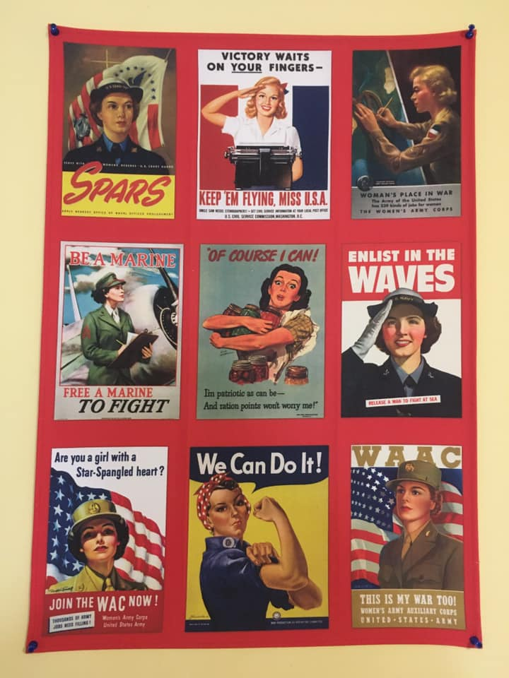

Here are three examples of Covid-19 Pandemic Propaganda:

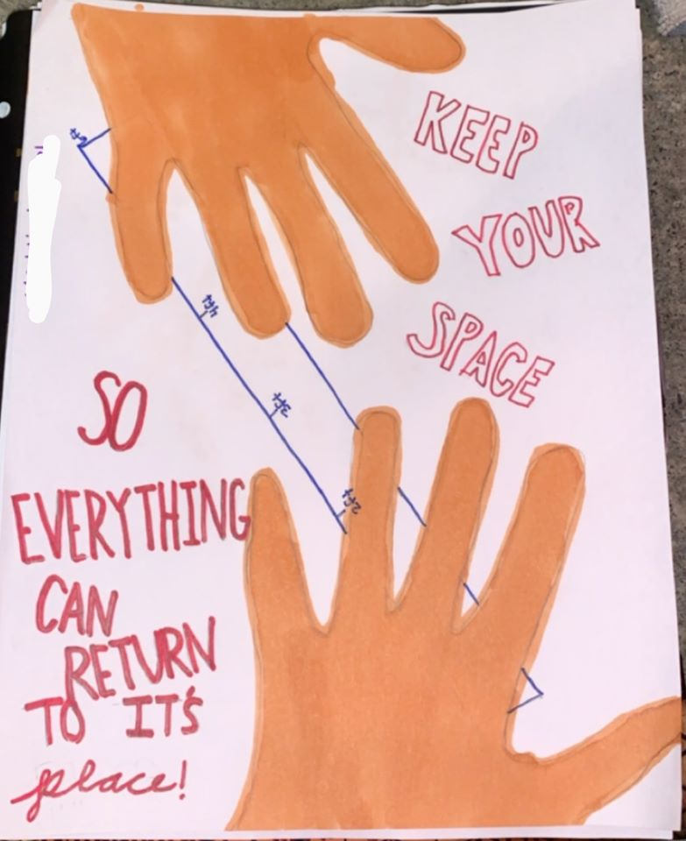

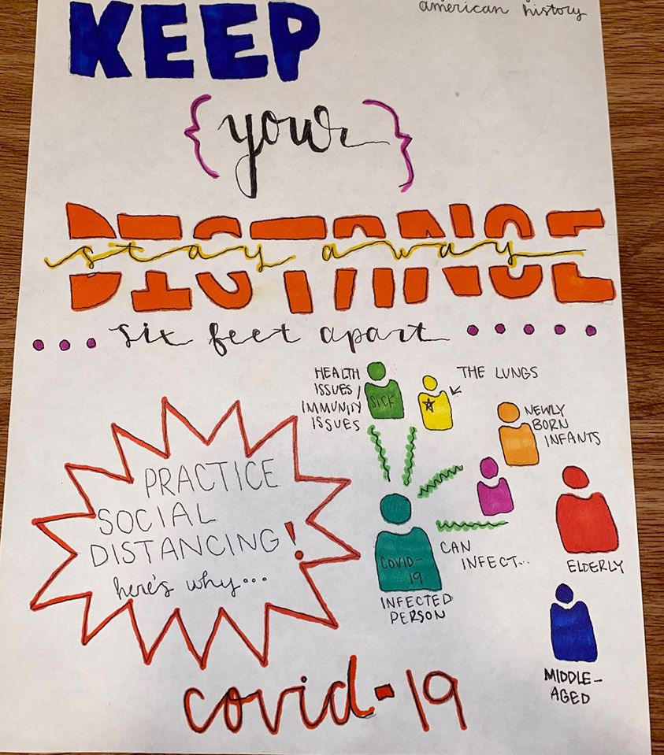

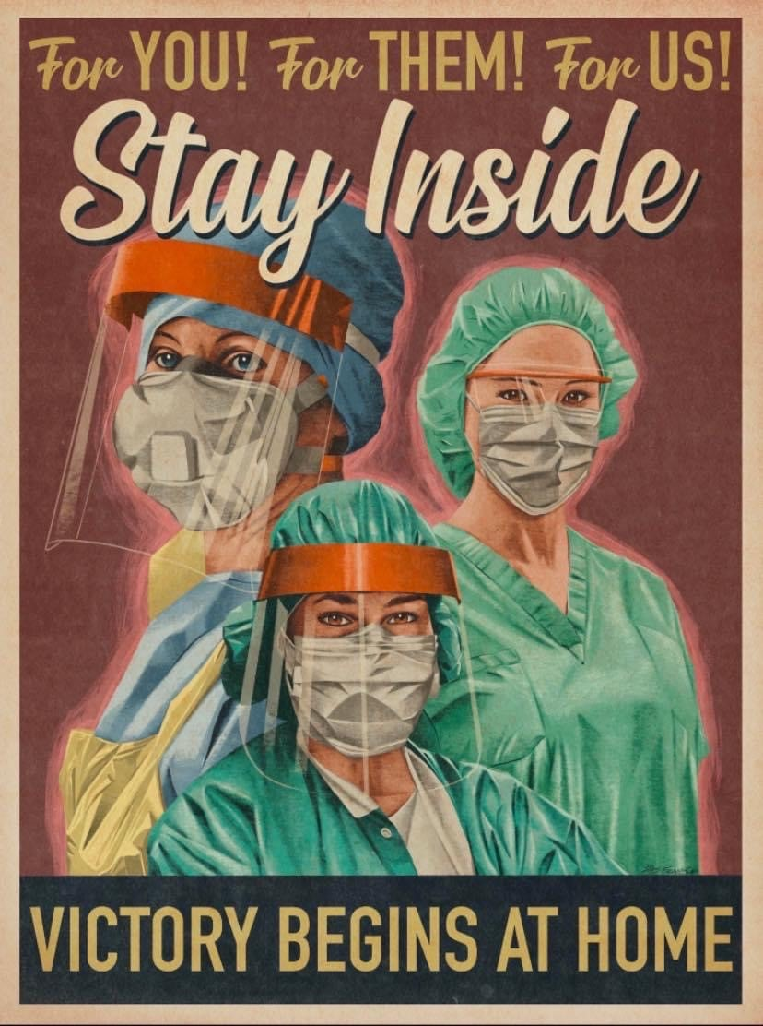
Rubric for Propaganda Poster
Poster Requirements
Is there persuasion/promotion? ….10 Points
Is there a phrase or message to help your poster? ….5 points
Is there color/graphics to complement your message? ….5 points

Overall Detail/Effort
Is there obvious evidence of effort? ….10 points
Is the poster free of glaring spelling/grammatical errors? ….5 Points

Paragraph on back of Poster
Is theme discussed?.....5 points
Is target audience identified?.....5 points
Is the intended meaning discussed?.......5 points
TOTAL: ….50 Points

DUE DATE: April 17th
Remember you can email me picture or text it to me in Remind. If neither of these options work, there is a drop off box located at the school.

