Health
Course Syllabus

Instructor: Brett Hardy Room: 2212 Email: brett.hardy@hcbe.net
Course Description:
This course is designed to emphasize the development of appropriate health habits and the necessity to continue such habits throughout life. Students will be advised of current health issues and updated information as it relates to their health and well-being.

Text:
Essential Health High School Curriculum, Human Relations Media (2010).
*This is an online curriculum that follows the required GPS standards for Health.
Glencoe Health, A Guide to Wellness, Glencoe/McGraw-Hill (2001).
*This textbook will be in your classroom daily. You will use the classroom book set and will not be required to carry one from your locker. Health books are not allowed to leave the classroom.
*Health Education follows the eight GPS performance standards listed on the following website:
www.georgiastandards.org

Materials:
-1” or 2” 3 ring binder with pockets (dividers are optional)
-Loose leaf notebook paper
-Pencil/Pen

Class Rules:

- RESPECT OTHERS! Show respect for all classmates and the course instructor.
- Follow all normal accepted behavior policies set forth by the classroom teacher, VHS, and Houston County located in your student handbook.
- BE ON TIME TO CLASS! The school tardy policy in the student handbook will be followed.
- Bring required materials to classroom.
- Stay in your seat at all times unless given permission to be out of your seat.
- No food or drink in the classroom.
- Teacher detention is held before school from 7:15-7:45. Detention will be served the next day.

Major Assessments 45%

*Chapter test Grades
-test grades include all written tests over the chapters covered in the text, approximately
nine tests this semester.

*Final Project
Students will present one end of the semester project. This project will consist of a 5-10 minute oral presentation, a 1-2 page written paper, and a powerpoint/prezi. The teacher must approve all project topics at least one week prior to your project date.

Minor Assessments 20%

*Notebook Check
-student’s notebook will be checked periodically for class notes/ handouts.

*Health Articles
-students will be responsible for TWO (2) current events about health on the last Friday of each month. The articles must be from a newspaper or a magazine. Newspaper articles must be from a newspaper printed in the past two weeks. Magazine articles must be from a magazine printed in 2008 or later. Health articles can be turned in until the following Wednesday for a 70.

*Projects
-students will be assigned a nutrition project and an inhalant project during the semester.

Daily Work 15%

*Study guides/class activities/quizzes/participation/effort
-students are expected to actively participate in classroom activities by bringing materials to class and actively participating in discussions, and will be graded accordingly.

Final Exam 20%

-This course includes a cumulative exam at the end of the semester. The final exam is worth 20% of the semester grade.

-It is the student’s responsibility to make arrangements and/or complete all work within 5 days of his/her return to school. The teacher has discretion as to when the student must make up tests. Books are to stay in the Health room unless there is a long term absence.

Google Classroom
To encourage blended learning, online assignments will be posted weekly through Google Classroom. At least one Google Classroom assignment per week will be graded and entered in Infinite Campus. Students should be familiar with how to navigate the online platform, communicate with their teacher, and submit assignments on time. If there are technology limitations, please notify the teacher.

Steps for Google Classroom Log-In:
Step One:
Go to the county’s website and click on SSO Portal.
Or, click on the link below:
https://portal.hcbe.net/_auth/Login.aspx?ru=L3Nzby9wb3J0YWw=

Step Two:
Students should sign in using their school/county username and password. If you have questions on your username and password, please ask your teacher.
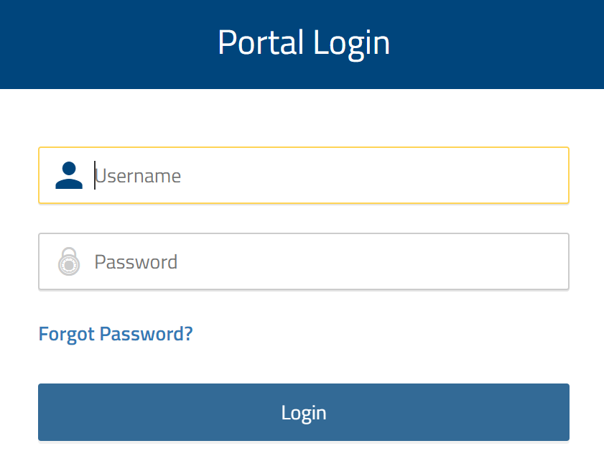

Step Three:
Students should click on the Google Classroom app.
Step Four:
Let’s get to work! When they sign into Google Classroom, they should see several “classrooms’. They simply click on ‘JOIN’ for each class.

Cyberbullying: As defined by Dictionary.com, “the act of harassing someone online by sending or posting mean messages.” Please keep in mind that the Edmodo communication system is designed to work as an extension of the classroom; therefore, anything done on the site through the access of a school course group code will be treated the same as if it were said aloud in the classroom. Inappropriate comments or use of the site can result in disciplinary action.

**I have read and understand all of the objectives, requirements, and expectations set forth by Coach Hardy for the 2021-2022 Health Class.

Student’s Name:_____________________________

Parent Signature:____________________________

**Must be signed by Parent/Guardian and returned no later than Friday, August 6, 2021.

