Temple High School
Financial Aid Night

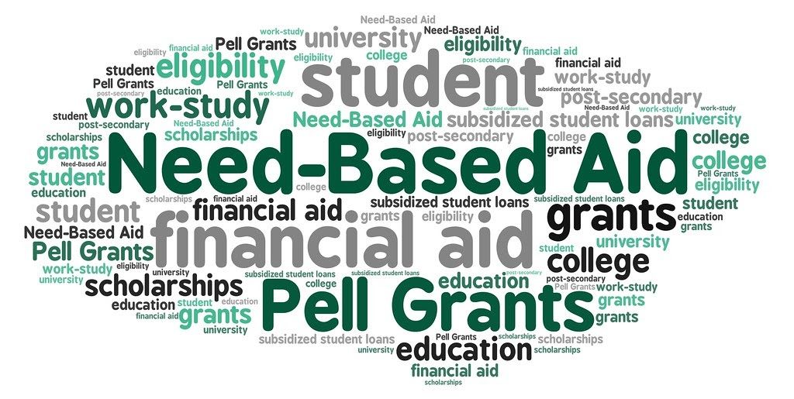

Temple High School will host a Financial Aid night for seniors and parents. A representative from Georgia Student Finance will share information about applying for financial aid and help families complete the Free Application for Federal Student Aid (FAFSA).

Please bring the following documents with you:
- SSN for student and parent
- 2018 Income tax return
- W-2 form(s)

DATE: January 23, 2020
PLACE: Temple High School Media Center
TIME: 6:00 PM

