Parent(s), Progress Reports go home tomorrow – return ASAP or at the latest Friday. Thank you for your continued support. Please be sure you are checking your child’s backpack and folder daily. Send a note, or email me if needed (karla.thompson@dcsms.org). You can also Stay Connected with Remind. Text @g7fc3f to 81010 Standard text message rates apply. Visit remind.com to learn more. Thanks to those parents already registered! ☺

Classroom Newsletter November 11,2019
Mrs. Thompson – 3rd Grade
Progress Reports go home tomorrow - Tuesday, November 12
Khamani Leonard
Star Student:
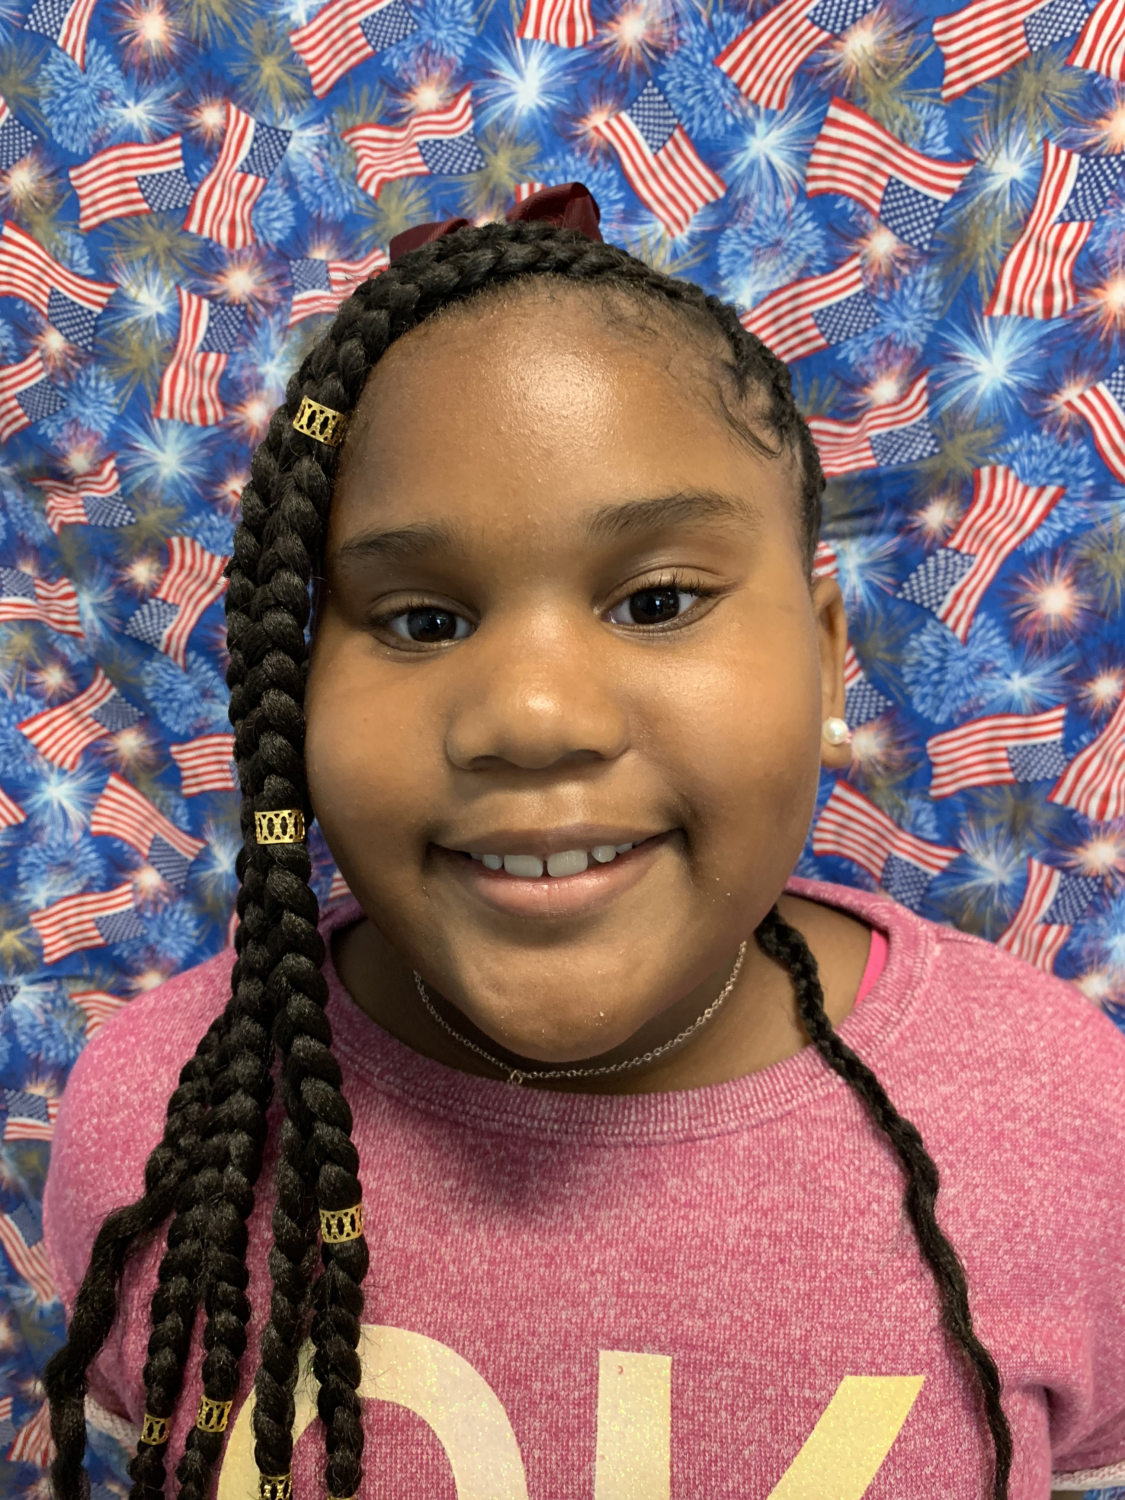

Characteristic: devoted
Teacher Notes: We are working hard to finish several writing pieces to share with you at our Writing Celebration in December. More info. coming soon! In addition to loving your kiddo, please be sure they are completing their homework, getting plenty of rest, eating healthy, and getting to school every day on time. Our class is striving to win the Perfect Attendance Contest!

Reading: central message/main idea & details, context clues
Writing: expository non-fiction; complete sentences
Math: word problems (2 step), area; review
Science: rocks & fossils Social Studies: map skills

Classroom
Topics

Lessons in life will be repeated until they are learned. – Frank Sonnenberg
Vocabulary – test 11/19
slog – walk slowly and heavily
commence – begin or start
flabbergasted – very surprised, or shocked or astonished
permissible – allowed or permitted
impermissible – not allowed or permitted
adventuresome – bold and ready for adventure
Daily Homework:
- Read, read, read – at least 20 minutes every day; complete daily section of Reading Homework page – How to jab a straw…
- Practice multiplication facts; complete daily section of Math Homework page – Q2:5

Novel Study of Hugo Cabret begins today.

Upcoming Tests:
Reading
- Vocabulary Quiz 11/12 & 11/19
- Reading Midpoint: 11/12
- Unit 4 Test: 11/19
Math
- Kicking It Quiz (multiplication facts): 11/12
- Math Test 11/15
- Math Midpoint – 11/20

