DCPS 1st Grade Week of 3/31 – 4/6
Parents,
Below you will find an outline of objectives for the week. We have included some links with videos, resources, and/or worksheets to help go along with each topic. We want to be clear that you are not expected to do it ALL. These are simply just suggestions that we know will help benefit your child during this time of distance learning. Thank you all again for everything you are doing at home to ensure that your child is still learning every day. We appreciate you!
First Grade Teachers
------------------------------------------------------------------------------------------
- Math- Review place value. Discuss the value of the tens and ones place and represent the number with base tens.
*Examples:
Value of 13 tens and ones place: Representing the number 32 with base tens:
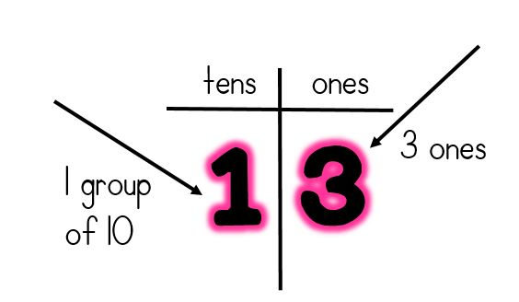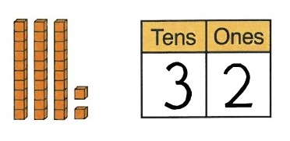
*Helpful videos:
https://youtu.be/1F3AycEDksY
https://youtu.be/_dHu5TFxPtk
*Follow these links for free place value printables:
https://www.education.com/worksheets/place-value-and-two-digit-numbers/
http://worksheets.us/collection/place-value-worksheets-tens-and-ones.html

- Reading- Begin making meaning story Birds: Winged and Feathered Animals (Discuss wonders before, during, and after the story. Identify and discuss non-fiction text features).
*Link to story:
https://youtu.be/o2BDlBhuj2I
*See the following videos about bird facts to go along with story:
https://youtu.be/jF0Id-hH9y4
https://youtu.be/Mu6b3u_95Ts
https://youtu.be/8vL_2rF8JHU
*Vocabulary words:
1. migrate – move from one country or area to another
2. dine - eat
3. amazing – very surprising
4. hover – stay in the air, flying right above something
*Write sentences with each vocabulary word.

- Writing- Informative writing about birds.
*Use facts gathered from the Birds: Winged and Feathered Animals book and additional videos provided above to write an informational piece about birds (at least 5 sentences).
*Choose your favorite bird and research more information about it. Write at least 5 sentences about the bird of your choice.
*Go on a nature walk and use your senses to write about a bird that you see. Write about how it sounds, how it looks, and what it is doing (include descriptive adjectives within your writing).

- Spelling- ar words

- yard
- arm
- sharp
- car
- far
- star
- park
- jar
- art
- chart
- around
- use
*Monday- Rainbow write
*Tuesday- Dot write
*Wednesday- Pyramid write
*Thursday- Write all spelling words 3 times. Then, write a sentence with each word.
*Friday- Take a “test” at home.

- Heggerty- Week 27
*Monday- https://youtu.be/Ipr0YnyWZOs
*Tuesday- https://youtu.be/Yw8IN21aRug
*Wednesday- https://youtu.be/uXb4perr728
*Thursday- https://youtu.be/jBiKJsYjAJo
*Friday- https://youtu.be/4y0jabVAEQQ

