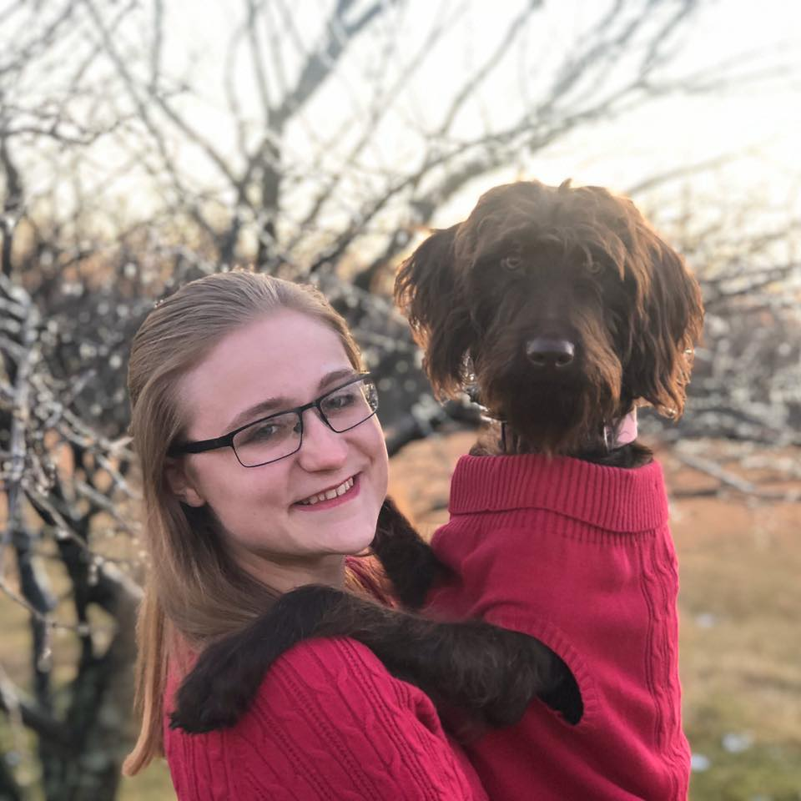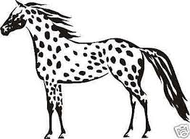

I am from Daisy, Missouri and currently co-own Oswald’s Appaloosa Horse Ranch with my family. I have a variety of farm animals that you will get to see pictures of and hear about throughout the year (Sorry in advance! ☺) and am the proud fur momma to a Labradoodle named Phelicity. Some of my favorite things include: the color purple, sweet tea, Skittles, horseback riding, and watching PBR and rodeos.

**a little about me**

My name is Alexis Oswald and I am BEYOND EXSTATIC to be your child’s teacher at APS for the 2020-2021 school year! I look forward to getting to know you and your child through this unknown, wacky year!

**communication**

**teaching background**

**email:** [aoswald@altenburgps.eduk12.net](mailto:aoswald@altenburgps.eduk12.net)

**phone number:** 573-576-1458

You can also communicate with me about your child through your student’s assignment notebook or through Class Dojo.

If you have any questions, concerns, or information you feel I should know about your student, please feel free to contact me anytime.

This is my first year teaching and I am excited to get to share it with you. I am an honors graduate of Southeast Missouri State University, where I majored in Elementary Education.

**Welcome to**

**Ms. Oswald’s Class!**