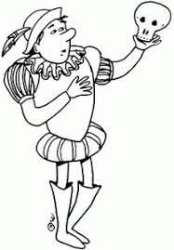
Welcome to British Literature
Teacher: Ginger Smith
__________________________

Goals: The goal of this class is to get you ready for the EOC and eventually college, tech school or the working world. Being literate is one of the major skills that the work world prizes and it’s one of the skills that will make you an attractive job candidate.
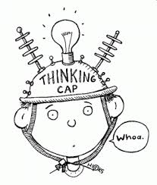
- To write essays on any topic using an organized method.
- To write excellent narratives anytime and anyplace.
- To know the kinds of research/writing that will help you succeed in college.
- To make you more excellent readers.
- To show so much growth on the EOC that no one will believe it!
___________________________________
Teacher Expectations:
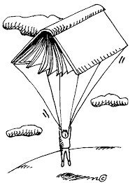
- That you will focus on class like the adults you are.
- We have a new curriculum and format for class which will require all of us to focus and concentrate. Repeatedly disrupting class learning could result in a write up.
- Making fun of people/bullying is not allowed in any fashion.
- I expect you to have a good attitude about 90% of the time. Everyone has a bad day, but you’d be surprised what you can do just by TRYING. Those successful people you want to be like…they are not successful because they are lucky, they are successful because they TRY and WORK HARD.
- We won’t do everything right the first time, but we will have a fun time learning from our mistakes and getting better and better.
- Cell phones must be put away when you are in class. I should not see your phone on your desk or in your hand. I do not have my phone out in class and you shouldn’t either. This is not only my rule, but a TCS rule.
- Earbuds should ONLY be used when the teacher says. I do not want to see them hanging around your ears or your neck. This is not just my rule, but a TCS rule.
- I can take your phone if you have it out, so do us both the professional courtesy of keeping it hidden away.

Behavior Policy:
- No talking when the teachers are talking.
- Treat others with respect and courtesy. Be polite. Help others in our room when you are able.
- Use time wisely. No playing. There is no time for off task behavior. If you have extra time, you should read a book!
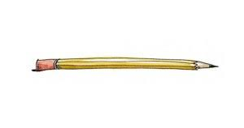
___________________________________

Supplies:
- Pens (blue or black ink)
- Pencils
- Paper and Notebook (preferably one with a few sections.)
- Highlighters
________________
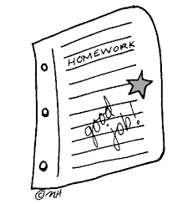
Grading:
40% Writing projects and tests (Writescore benchmark or teacher made.)
25% homework and classwork
15% quizzes and participation

_________________
Topics: We have a totally new curriculum this year so it will be a learning experience for all of us. Honestly, this is my favorite class, and I think you are going to like studying Hamlet in depth! This play has everything: drama, poisoning, death, madness, and murder!!!
- We will be doing a “deep dive” into Hamlet. This is Shakespeare’s most famous play (besides Romeo and Juliet). We are going to talk about characters and their motivations, vocabulary and plot. How does Shakespeare keep people focused and interested in this play?
- We will be looking at other forms of literature that play off of Hamlet. This play has inspired plays and poetry, as well as short stories. We will be looking at some of them.
- For some of you that have trouble with Shakespeare, we have a book that has both the Modern English and Shakespearean version so you can all do well!!
- You guys will, of course, have a chance to do some college level writing on Hamlet, as well as a research paper on the death penalty. Knowing you guys, I think you will enjoy the debate. (Ever hear of Ted Bundy? What about Charles Manson?) We will do a few case studies to help you prove your case for or against the death penalty.

Extra Help Policy:
I am always here to help you before or after school and at lunch if you need extra help. I consider that a teacher’s job.
BUT if you goof off all year then want me to give you extra credit in December, you may end up disappointed. Don’t wait too late.

