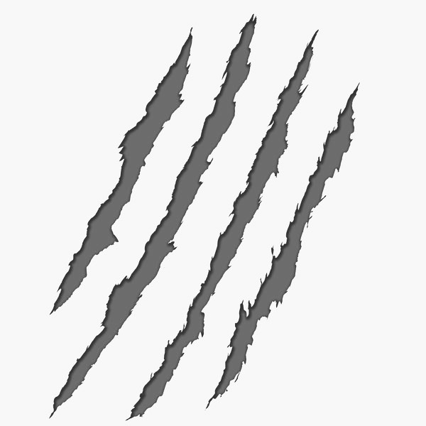

Shaun Banger
Myles Colom
Timmy Welch
Owen O’Briant
Steven Roberson
Caleb Rucker
Georden Saulsberry
Hayzen Shelton
Austin Simpson
Langston Simpson
Blake Thompson
Caleb Litt
John Butler

