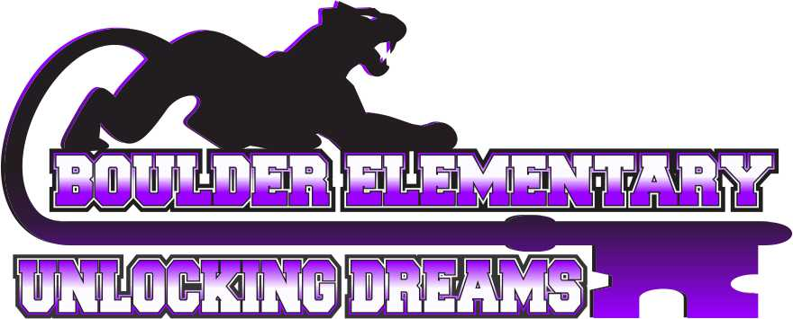
P.O. Box 1346
Boulder, Montana 59632
Phone Number 406.225.3316
Fax Number 406.225.9218
bgs.k12.mt.us

6/18/21

Dear Parents and Guardians:

On Wednesday, June 16th the Boulder Elementary School Board discussed and voted on the school’s mask policy. Starting in July, masks will be optional, or your personal choice. While indoors until then, we will be enforcing the current school policy of masks being worn indoors.

As partners, we will continue to keep students safe while they are in our program. Meals will be served in the classroom. Cleaning, disinfecting, and proper hand sanitation will continue. Each room has an air purifier and proper ventilation. If a student shows symptoms, they will be isolated and asked to wear a mask. Please continue to screen your child(ren) for symptoms before coming to the program each day.

We will continue to monitor cases in our county and address the need to reinstate the mask policy if recommended by the County Health Department. Boulder Elementary School’s sickness guide is attached for your reference. Please contact me with any questions or concerns.

Sincerely,

Rochelle Hesford
21st Century Grant Director

