Name:
Date:

Chapter 17- Section 2
The Axis Advances

- Vocabulary- define these words

- Blitzkrieg-

- Luftwaffe-

- Dunkirk-

- Vichy-

- General Erwin Rommel-

- Concentration camps-

- Holocaust-

- Lend-Lease Act-
B. Winston Churchill’s (England) defiance gave voice to the determination of the British.
- How did Churchill give weight to his speech?
His speech:
“We shall defend our island, whatever the cost may be, we shall fight on the beaches, we shall fight on the landing grounds, we shall fight in the fields and in the streets, we shall fight in the hills; we shall never surrender.”
- Winston Churchill, June 4, 1940

Answer for number 9:

10-19. In the chart below, you will record the sequence of events in WWII. I have provided the dates; you provide the event. (when you research this, you would ask in the search engine something like this- What happened in September 1939? You will get the answer, then type it in the chart.
September 1939:

April 1940:
May 1940:
June 1940:
September 1940:
October 1940:
June 1941:
June 1941: (2 events happened on this date)
September 1941:
December 1941:

20-25. This is a concept diagram about the Nazi and Japanese occupation during WWII. The sentences below are features of the Nazi and Japanese occupations. They are lettered A-F. Decide which feature you think belongs in which occupation and put the correct letters in the circles. These features are characteristics of the Nazis and the Japanese. You have learned enough about both to be able to complete this table accurately. However, you may also research these topics to learn what you do not know to complete this activity correctly.

Nazi
occupation
Japanese
occupation

A. Destroyed cities and towns
B. Jews and others sent to prison camps
C. Killed and tortured citizens
D. Planned genocide (the deliberate killing of a large group of people, especially those of a particular ethnic group or nation) of all European Jews
E. Slavs considered inferior
F. Treated conquered people brutally

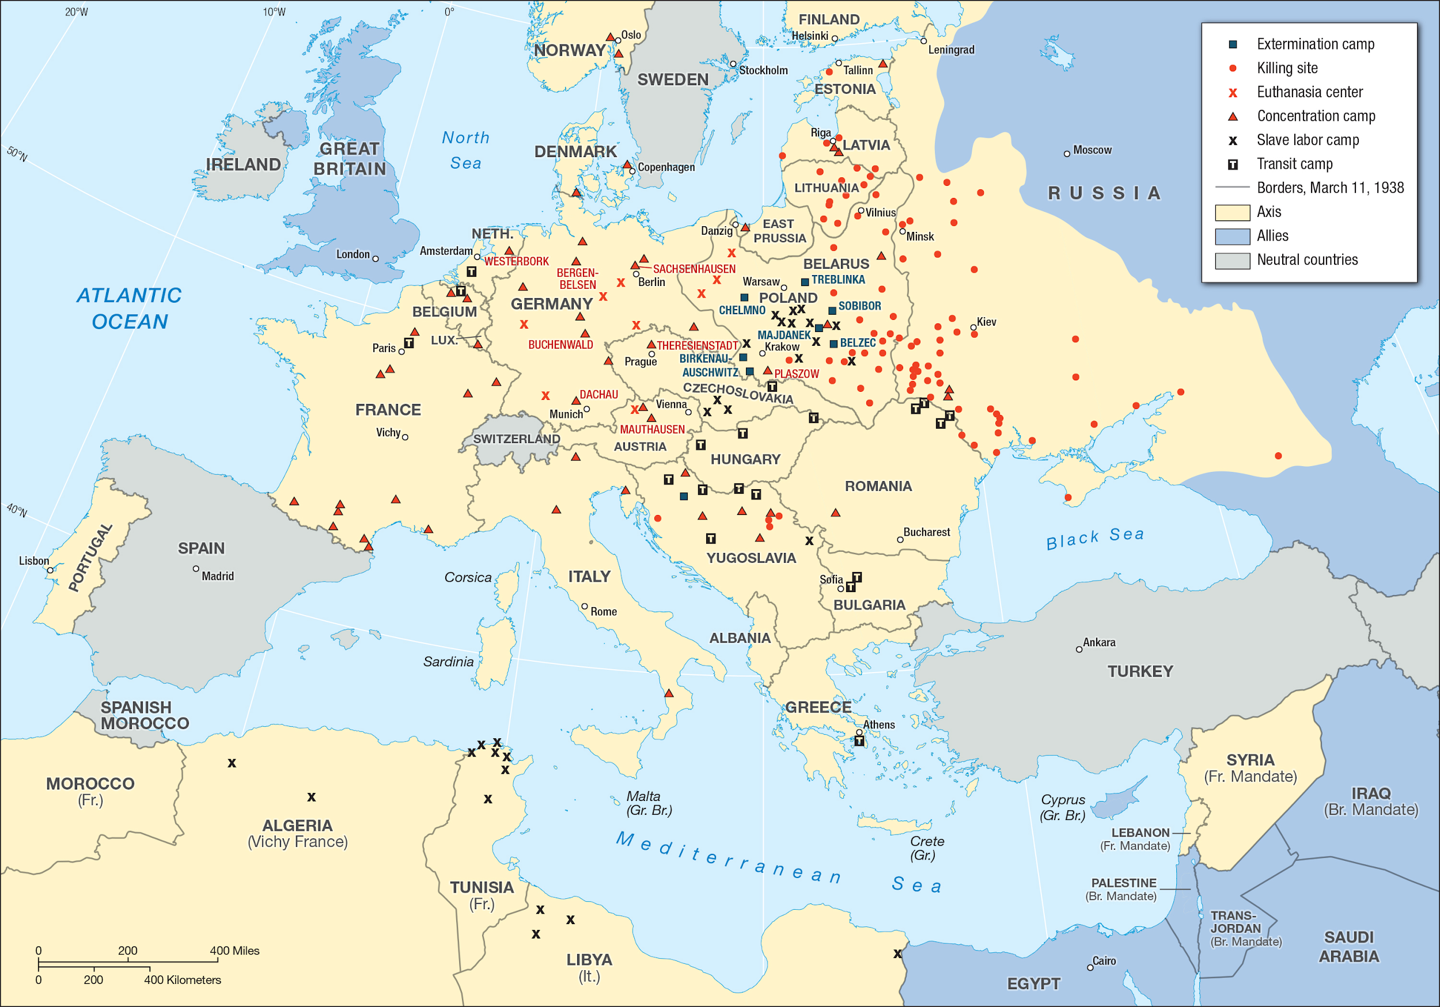
Look at the map above and answer the following questions:
26. Where were the extermination (death) camps located?

27. How did this location reflect the goal of the “Final Solution” (the Nazi policy of exterminating European Jews)?
28. Look at the graph below. How does the graph show the horror of the Holocaust?

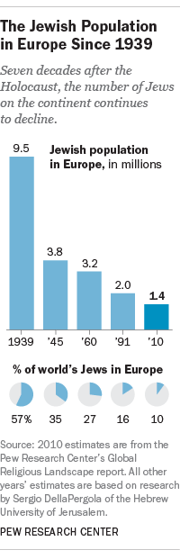

Damage at Pearl Harbor
U.S. ships sunk or damaged | 19
U.S. aircraft destroyed | 188
Americans killed | 2,348
Americans injured | 1,109

The chart above shows the damage that occurred at Pearl Harbor when Japanese airplanes bombed the American fleet at Pearl Harbor in Hawaii.

Background Information:
- What was the United States policy of isolationism?
Isolationism refers to America's longstanding reluctance to become involved in European alliances and wars. Isolationists held the view that America's perspective on the world was different from that of European societies and that America could advance the cause of freedom and democracy by means other than war.

Read the following paragraph and answer the question at the end:

December 7, 1941
On the sleepy Sunday morning of December 7, 1941, the military complex at Pearl Harbor was suddenly jolted awake by a surprise attack. Planes screamed down from the sky, dropping bombs and torpedoes. Americans were shocked and horrified by the attacks.

29. How did Pearl Harbor change the isolationist policies of the United States? (Refer to background information above and you may do research to help you answer this question.)

