Free Services for your family!

Your children may be eligible to receive services through our program. Please answer the following questions to determine if they qualify.

- In the last 3 years, has your family moved to another city, county or state? Yes ☐ No☐

- Do you or have you worked (in the last 3 years) in any of the following activities? Has anyone in your family?
☐ Processing / Packing food or meats
☐ Nursery / Greenhouse
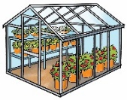

Yes ☐ No☐
(Indicate what activity)
Vegetables, beef, chicken, pork, etc.
Sowing, planting, picking, harvesting, packing, sorting (tomatoes, strawberries, cotton), land preparation, irrigation, fumigation,
☐ Field work / Agriculture
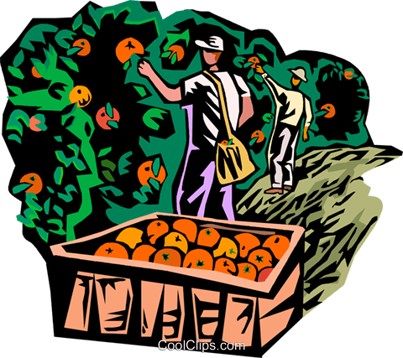

Milking, feeding, coraling, etc.

☐ Dairy / Cattle raising
☐ Fishing / Fish processing
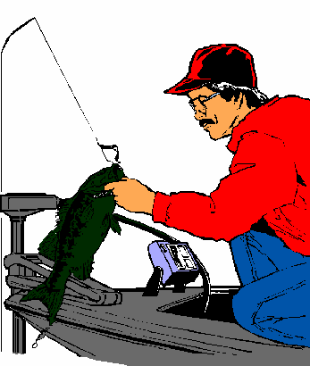

☐ Forestry work
Plant, cultivate, harvest trees, etc.
Plant, cultivate, plant flowers and plants, etc.
Sort and pack fish and seafood, etc.

If you answered "yes" to the above questions, you and your family may be eligible to receive services under the Migrant Education Program.

NAME:
ADDRESS CITY STATE ZIP CODE
PHONE NUMBER:

What does our program offer?

Free lunch in school, school supplies, summer programs, in-home tutoring, preparation for college, help with school enrollment, English classes, lending library, references to community resources (social, legal, health, etc.), and parent engagement programs.

Phone number: (615) 924-1497 Email: MEP@conexionamericas.org

