
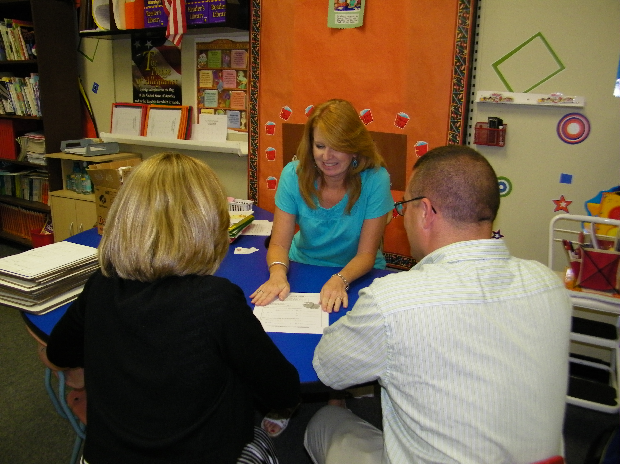
While home involvement is most important, your involvement with the school is also critical to your child’s success. How can you get more involved with your child’s school life? There are a number of ways.

- Join the parent-teacher association
- Attend open houses and back-to-school nights
- Read the school newsletters
- Participate in after-school events
- Get to know your child’s teachers
- Support your child in school activities
- Volunteer to assist with school functions and extra-curricular activities
- Register for Parent Portal and Notify Me
- Request and attend parent-teacher conferences
Research shows that parent support is more important to school success than a student’s IQ, economic status or school setting. Parent influence everything from their child’s reading level to test scores. There are many ways to be involved both at home and in the school. And the benefits of parental involvement are overwhelming. They include:

- Higher grades and test scores
- Better behavior and more positive attitudes
- Higher graduation rate
- Better attendance at school
- More homework completed
- Fewer placements in special education
- Greater enrollment in post-secondary education

WANT YOUR CHILD TO MAKE SUCCESSFUL CAREER DECISIONS?
Why should you be involved with your child’s education?
210 EAST MORRIS BLVD
MORRISTOWN, TN 37813
WWW.HCBOE.NET
HAMBLEN COUNTY DEPARTMENT OF EDUCATION
PARENT INVOLVEMENT =
STUDENT SUCCESS

Visit your child’s school frequently. Call and make an appointment to talk to your child’s counselors and teachers. By visiting the school you can discover:
- How your child is doing
- How your child interacts with others.
- If the teacher is having disciplinary problems with you child.
- What activities you can do at home to help your child in school

Check with the office at your child’s school for directions and information about registering for Parent Portal and NotifyMe.

Parent involvement at school sometimes decreases in the middle and high school years. Maturing children have a need to develop a sense of independence; however, it is important to remember that you, as a parent, still have a strong influence on your child’s life . Remain involved at home and continue to provide support as your child approaches adolescence.
- Keep the lines of communication open.
- Set fair and consistent rules.
- Support your child’s future.
- Continue to show that education is important.
- Set a good example
- Create time for your family to do activities together

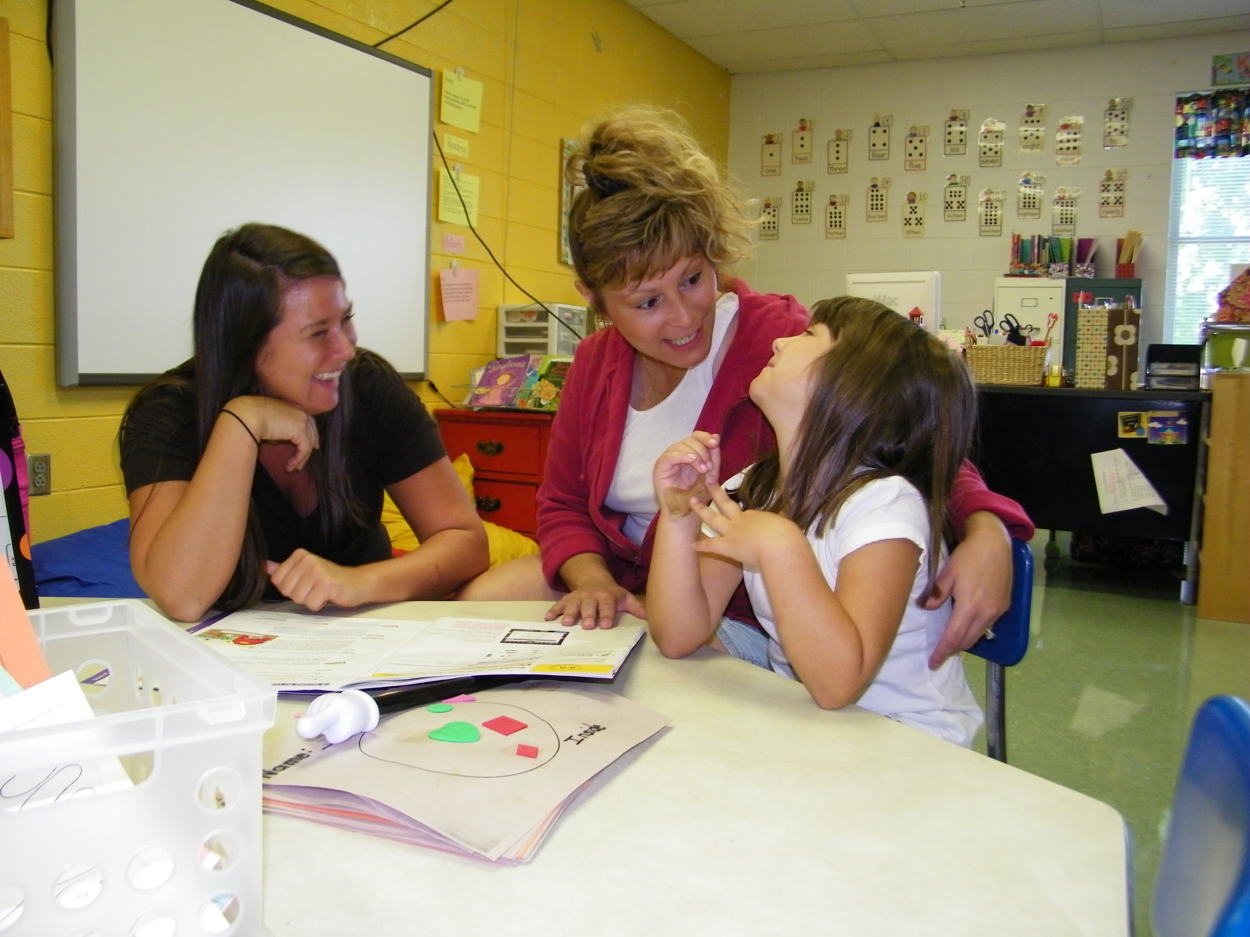
YOU ARE THE BIGGEST INFLUENCE IN YOUR CHILD’S LIFE…USE THAT INFLUENCE TO PUT YOUR CHILD ON THE PATHWAY TO SUCCESS.
Foundation Skills Needed for Career Success
Basic Skills
- Reading
- Writing
- Arithmetic and Math
- Speaking and listening
Thinking Skills
- Ability to Learn, Reason, and Think Creatively
- Make Decisions
- Solve Problems
Personal Qualities
- Individual Responsibility
- Self-Esteem and Self-Management
- Sociability
- Integrity
- Attendance
- Drug-free
Information
- Interpret and Evaluate Information
- Organize and Maintain Information
Technology
- Select and use technology to solve problems
Interpersonal Skills
- Team Work
- Work with Diversity
- Collaborate
- Lead

PARENTS MAKE A
DIFFERENCE.
Parental involvement begins at home with you and your children. By creating a positive home environment and encouraging communication, you are stimulating the learning process.
Some simple ways to encourage learning are:

1. Encourage Reading and Writing

Studies show that children who read at home perform better in school. Keep books, magazines, and newspapers in your home. Take your child to the library and help him or her get a library card. Discuss what your child reads. Read to your child.

2. Make School Important; Make it a Priority

The first step to your child’s school success is for you to be supportive of school and education. If school is not important to you, it will not be important to your child.

