MGM ANIME CLUB

Anime Club Permission Form

Hello! My name is Nellie Shiver and I am the sponsor of MGM’s Anime Club. Your son/daughter is interested in joining the anime club’s screenings. Anime is Japanese Animation. However, just because it is “cartoons” does not mean that it is necessarily appropriate for all audiences. There are many shows that are just fine for all ages – but at the same time, there are also many shows that are aimed at an older teen audience. MGM’s Anime Club is for teens, in grades 9 – 12.

These are the different age ratings on anime and what they mean (from http://www.tvguidelines.org/:

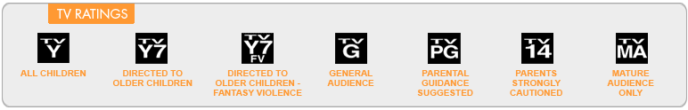

Most Anime Club screenings are rated TV PG and TV 14. We will NOT be screening any programs with the rating of TV MA.

I pre-screen all titles that the anime club will watch.

If you have any questions, please do not hesitate to call me at 251-221-3153 or email me at nshiver@mcpss.com.

I would be happy to answer any questions you may have.

I, the undersigned, Parent/Guardian of ________________________________________ grant permission for my student to attend the MGM Anime Club meetings and watch the screenings that occur.

Parent/Guardian Signature: _________________________________
Date: _______________

Student Name: ______________________________ Grade: ___________

