Parent(s), graded papers go home tomorrow. Please be sure you are checking your child’s backpack and folder daily. Continue to encourage reading and homework completion. Write any comments or suggestions below, send additional note, or email me if needed (karla.thompson@dcsms.org). Thank you for your support!

Classroom Newsletter September 9,2019
Mrs. Thompson – 3rd Grade
All for Books Coin Drive Complete
We collected over $135!
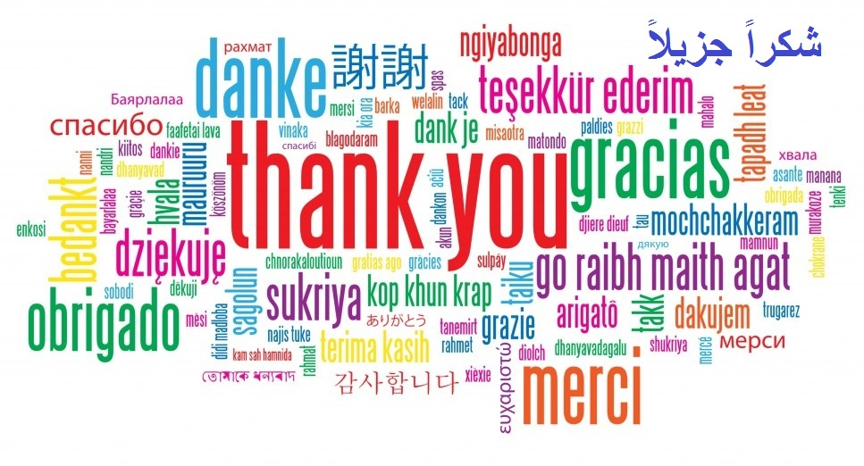
McKenzie Hardemon
Star Student:
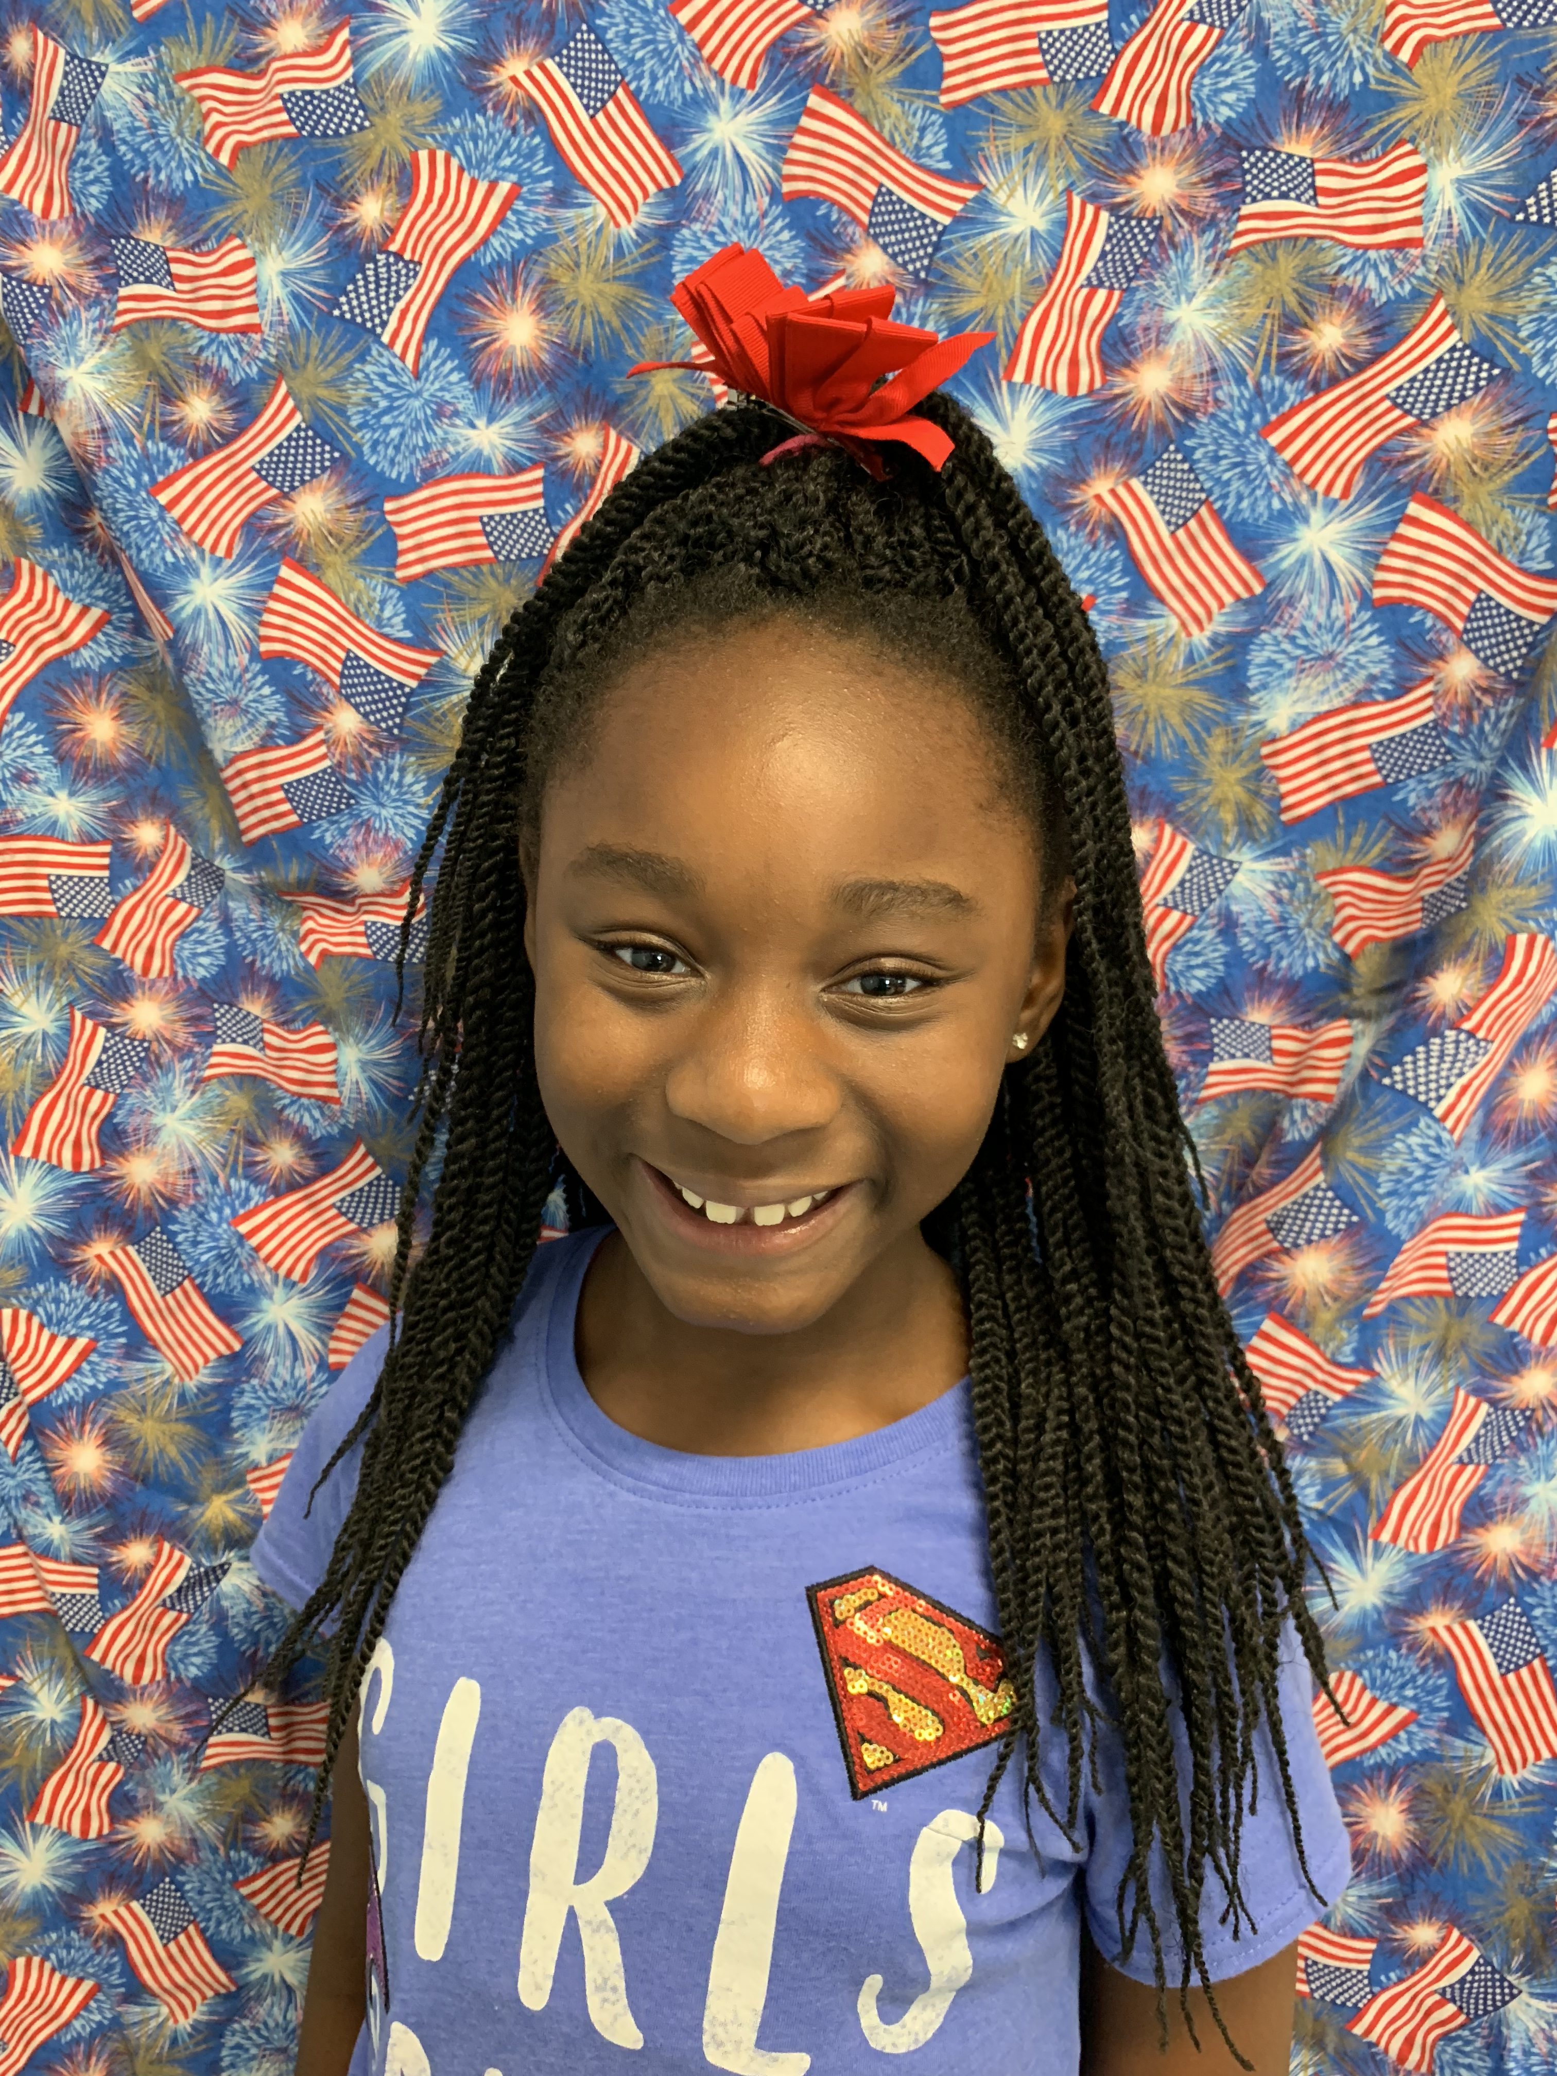

Characteristic: optimistic
Teacher Notes: Thank you so much for replying to my request for conference information. I am sending home a letter today with a proposed meeting/talking time. Please let me know if there is any kind of conflict, and we’ll reschedule. Your involvement is key to your child’s success! 😊

Reading: central message with key details to support; character traits
Writing: personal narrative; complete sentences
Math: multiplication & properties
Science: animal adaptations Social Studies: The Constitution & 7 Habits # 5
(Seek first to understand,
then to be understood)

Classroom
Topics

Put First Things First – Work First, Then Play!
Vocabulary Focus:
floppy – soft and hanging loosely
recall – remember
clatter – bang together or rattle noisily disaster – event that causes a lot of damage or suffering
celebration – happy event held to honor a special occasion
retrieve – bring or get something back
Daily Homework:
- Read, read, read – at least 20 minutes every day; complete daily section of Reading Homework page – The Mauna Loa Volcano…
- Practice multiplication facts; complete daily section of Math Homework page – Q1:5

Upcoming Tests:
Reading
- Vocabulary Quiz (words from 9/3): 9/10
- Reading Mid-term Test: Tuesday, 9/10
Math
- Kicking It Quiz (multiplication facts): 9/10
- Math Mid-term Test: Thursday, 9/12

Stay Connected!
Please sign up for REMIND to receive texts about Mrs. Thompson’s classroom/school activities.
Text @g7fc3f to 81010
Standard text message rates apply. Visit remind.com to learn more.
Thanks to those parents already registered! ☺

