9th Grade - AP World History Summer Assignment
Welcome to Murphy!!! I look forward to having you in my class this year!!
Please log in to Google Classroom and complete the following activities BEFORE school starts on August 6th:
Instructions to join your Google Classroom:

1. Go to www.classroom.google.com If you already have a Gmail account it may take you to a page that looks like this:
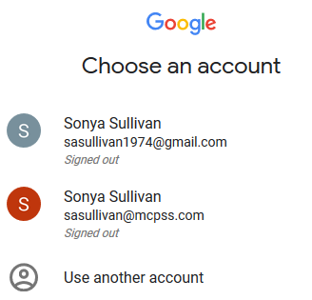 If this is what you see this then you need to click Use Another Account and sign in using your MCPSS email login and password. You will NOT use an @gmail.com account. MCPSS has set up your MCPSS account to link to Google. An example email address may be ABC123456@stu.mcpss.com.
Or you may just see a Google page and will need to sign in by clicking the button shown below:
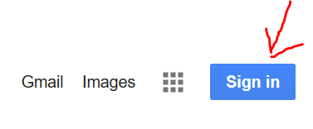
2. Choose “ADD ACCOUNT.”

3. Sign in using your MCPSS email login and password. You will NOT use an @gmail.com account. MCPSS has set up your MCPSS account to link to Google. An example email address may be ABC123456@stu.mcpss.com.
4. This MCPSS Google account will show up as a second account if you already have a gmail account. In order to work within the Google Suite for MCPSS, you must be logged in under the MCPSS Google account. Outside logins will not allow access to school related Google applications. Sign in again on the MCPSS sign in page.

5. Click on “the waffle” then choose Classroom.
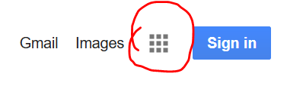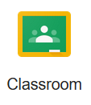
6. Click on the “+” and choose “join class.” Enter the class code t9srg9
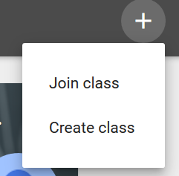

7. After joining the class, click on the CLASSWORK tab. The assignments are numbered. They need to be completed in order.

8. You should log in to the classroom by June 15, 2019. This will give you time to let me know if you are having any technical difficulties. Please email me right away if you have problems logging in or accessing the classroom or assignment. sasullivan@mcpss.com Remember your assignments must be completed by August 5th.

9. Your first test grade will be a reading quiz over the 2 chapters you have to read.

