Do you Like Going on Trips?  Then band is the program for you. The Huntington Band travels to many different places during the school year such as Universal Studios, Six Flags, Wild Adventures and many other trips locally and in the state of Georgia. | DO YOU WANT TO BE APART OF SOMETHING FUN AND SUCCESFUL?  Our award winning band program performs at different competitions and state festivals throughout the year. Our Band continues to receive outstanding ratings and everyone has fun being a part of something rewarding. | Be Part of the  Band Tradition at Huntington Middle School | HUNTINGTON  MIDDLE SCHOOL BAND  Director of Bands  Tim Pietrofere
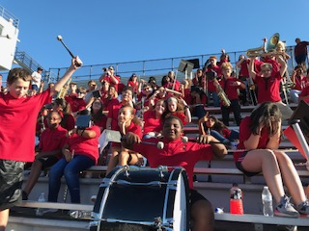 | WHY MUSIC? WHY BAND?  It might be more appropriate to ask: WHY NOT MUSIC? WHY NOT BAND? It is evident music education should be experienced by every student. We, as a culture, will be best served if the hearts and minds of our youth are filled with the knowledge and the understanding of MUSIC. The time has come, the time is now:  STRIKE UP THE BAND! | 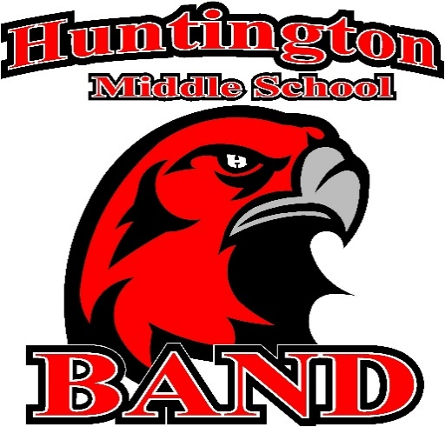 | 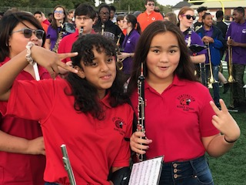
 | 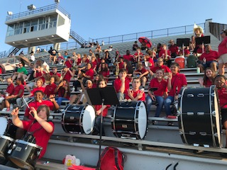 | Huntington Middle School Band  •••  206 Wellborn Rd.  Warner Robins, GA 31088  •••  478-542-2240  •••  timothy.pietrofere@hcbe.net  •••

I want to sign up for band, but I don’t know how to play an instrument. How can I be in band? 99% of all beginners have never played a wind or percussion instrument in their lifetime. Beginning band is designed to teach you everything you need to know to play an instrument and be in a performing band.  SCAN HERE | - Register here for band. |  |  | 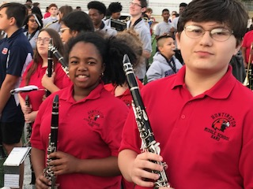
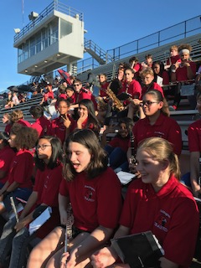 | How Do I Know What Instrument I Should Play?  The band director will meet with each student in the fall and help you select the right instrument for you. | 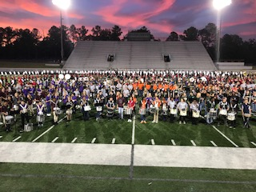 |  | Huntington Middle School Band  Come Be A Part of the EXPERIENCE.
 | 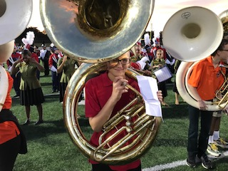 |  | What Instruments Can I Play?  You will be able to pick from:  Flute, Oboe, Clarinet, Saxophone, Bassoon, Trumpet, French Horn, Trombone, Baritone, Tuba, Percussion | 