What is the number shown below?  A) 407  B) 142  C) 124  D) 222 | Max had some marbles in the jar. He found 39 marbles in a box. Now Max has 84 marbles. How many marbles was in the jar? | How many tens are in 100?  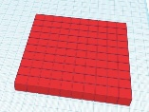  A) 1  B) 10  C) 100  D) 6
Davis feeds his dog at the time shown on the clock. What time does Davis feed his dog?  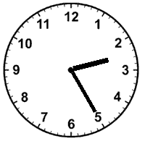  A) 5:10 a.m.  B) 5:10 p.m.  C) 2:25 a.m.  D) 2:25 p.m. | What is the number below?  A) 170  B) 176  C) 1,000  D) 761 | What is the value of the coins shown below?  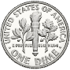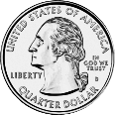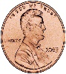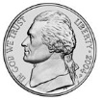  This Photo by Unknown Author is licensed under CC BY-SA  This Photo by Unknown Author is licensed under CC BY-SA  A) 92 cents  B) 87 cents  C) 102 cents  D) 107 cents
602 =  ___hundreds  ___ tens  ___ ones | 10 ones = ______ ten(s)  10 tens = _______hundred(s)  12 tens = _______  270 = ________ tens | Chloe drove 218 miles on Monday. She drove 329 miles on Tuesday. How many miles did Chloe drive in all?

