SUICIDE PREVENTION
PLAN

WESTERN LINE
SCHOOL DISTRICT

PURPOSE
The purpose of this guidance document is to protect the health and well-being of all Western Line School District students by having procedures in place to prevent, assess the risk of, intervene in, and respond to suicide.
The Western Line School District:
(a) recognizes that physical, behavioral, and emotional health is an integral component of a student’s educational outcomes;
(b) further recognizes that suicide is a leading cause of death among young people;
(c) has an ethical responsibility to take a proactive approach in preventing deaths by suicide; and
(d) acknowledges the school’s role in providing an environment which is sensitive to individual and societal factors that place youth at greater risk for suicide and one which helps to foster positive youth development.
This procedure guideline is meant to be paired with other policies supporting the emotional and behavioral health of students more broadly. Specifically, this document is meant to be applied in accordance with the district’s Child Find obligations.

SCOPE
This procedure guideline covers actions that take place in the Western Line School District schools, on school property, at school-sponsored functions and activities, on school buses or vehicles and at bus stops, and at school sponsored out-of-school events where school staff are present. This procedure guideline applies to the entire school community, including Western Line School District educators, school and district staff, students, parents/guardians, and volunteers. This procedure guideline will also cover appropriate school responses to suicidal or high risk behaviors that take place outside of the school environment.

PREVENTION
1. District Procedure Implementation: A district level suicide prevention coordinator is required to be designated by the Superintendent. This may be an existing staff person. The district suicide prevention coordinator will be responsible for planning and coordinating implementation of the policy for the school district.
Each school principal of Western Line School District can designate a school suicide prevention coordinator to act as a point of contact in each school for issues relating to suicide prevention and policy implementation. This may be an existing staff person. All staff members shall report students they believe to be at elevated risk for suicide to the school suicide prevention coordinator.
2. Staff Professional Development: In compliance with Mississippi House Bill 263, Western Line School District trained all school district employees in suicide prevention during the 2017-2018 school year. After 2017-2018, all new employees of Western Line School District receive training. The professional development series contains information regarding groups of students at elevated risk for suicide, including those living with mental and/or substance use disorders, those who engage in self-harm or have attempted suicide, those in out-of-home settings, those experiencing homelessness, American Indian/Alaska Native students, LGBTQ (lesbian, gay, bisexual, transgender, and questioning) students, students bereaved by suicide, and those with medical conditions or certain types of disabilities. Western Line School District will also take into consideration any recent traumatic events that may increase the potential for suicide threats or completion and provide additional professional development as needed.

See Appendix E for “Suicide Prevention Training Implementation Guidelines” for professional development series course trainings and instructions for implementation.

3. Publication and Distribution: Western Line School District will distribute the district policy annually and it may include student and teacher handbooks and the district/school website. Western Line School District will include the National Suicide Prevention Lifeline’s logo with phone number and website in distributions. See Appendix B.
4. Youth Suicide Prevention Programming: In addition to developmentally appropriate, student centered education materials regarding suicide prevention that are integrated in Health Science classes, schools are encouraged to invite the MS Department of Mental Health or other organizations to provide presentations and resources to students about warning signs and prevention techniques. The MS Department of Mental Health can be reached at 1-601-359-1288.

INTERVENTION
Assessment and Referral
When a student is identified by a staff person as potentially suicidal, i.e., verbalizes about suicide, presents overt risk factors such as agitation or intoxication, the act of self-harm occurs, or a student self-refers, the student will be seen by a school employed mental health professional within the same school day to assess risk and facilitate referral. If there is not mental health professional available, a school nurse or administrator will fill this role until a mental health professional can be brought in.
See Appendix C for Community Mental Health Center and Mobile Crisis Response Team contact information.
For youth at risk:
1. School staff will continuously supervise the student to ensure their safety.
2. The principal and school and/or district suicide prevention coordinator will be made aware of the situation as soon as reasonably possible.
3. The school employed mental health professional or principal will contact the student’s parent or guardian, as described in the Parental Notification and Involvement section, and will assist the family with urgent referral. When appropriate, this may include calling emergency services or bringing the student to the local Emergency Department, but in most cases will involve setting up an outpatient mental health or primary care appointment and communicating the reason for referral to the healthcare provider.
4. Staff will ask the student’s parent or guardian for written permission to discuss the student’s health with outside care, if appropriate.

IN-SCHOOL SUICIDE ATTEMPTS
In the case of an in-school suicide attempt, the health and safety of the student is paramount. In these situations:
1. First aide will be rendered until professional medical treatment and/or transportation can be received, following Western Line School District emergency medical procedures.
2. School staff will supervise the student to ensure their safety.
3. Staff will move all other students out of the immediate area as soon as possible.
4. If appropriate, staff will immediately request a mental health assessment for the youth. See Appendix C for list of Community Mental Health Center and Mobile Crisis Response Team contact information.
5. The school employed mental health professional or principal will contact the student’s parent or guardian, as described in the Parental Notification and Involvement section.
6. Staff will immediately notify the principal or school and/or district suicide prevention coordinator regarding in-school suicide attempts.
7. The school will engage as necessary the crisis team (See Appendix A) to assess whether additional steps should be taken to ensure student safety and well-being.

RE-ENTRY PROCEDURE
For students returning to school after a mental health crisis (e.g., suicide attempt or psychiatric hospitalization), a school employed mental health professional, the principal, or designee will meet with the student’s parent or guardian, and if appropriate, meet with the student to discuss re-entry and appropriate next steps to ensure the student’s readiness for return to school.
1. A school employed mental health professional or other designee will be identified to coordinate with the student, their parent or guardian, and any outside mental health care providers.
2. The parent or guardian will provide documentation from a mental health care provider of choice that the student has undergone examination and that they are no longer a danger to themselves or others.
3. The designated staff person will periodically check in with the student to help the student readjust to the school community and address any ongoing concerns.

OUT-OF-SCHOOL SUICIDE ATTEMPTS
If a Western Line School District staff member becomes aware of a suicide attempt by a student that is in progress in an out-of-school location, the staff member will:
1. Call the police and/or emergency medical services, such as 911.
2. Inform the student’s parent or guardian.
3. Inform the school and/or district suicide prevention coordinator and principal.
If the student contacts the staff member and expresses suicidal ideation, the staff member should maintain contact with the student (either in person, online, or on the phone). The staff member should then enlist the assistance of another person to contact the police while maintaining verbal engagement with the student.

PARENTAL NOTIFICATION AND INVOLVEMENT
In situations where a student is assessed at risk for suicide or has made a suicide attempt, the student’s parent or guardian will be informed as soon as practicable by the principal, designee, or mental health professional. Staff will also seek parental permission to communicate with outside mental health care providers regarding their child.
If the principal, designee, or mental health professional believes, in their professional capacity, that contacting the parent or guardian would endanger the health or well-being of the student, they may delay such contact as appropriate. If contact is delayed, the reasons for the delay should be documented.

POSTVENTION
1. Development and Implementation of an Action Plan: The crisis team (see Appendix A) will develop an action plan to guide school response following a death by suicide. A meeting of the crisis team to implement the action plan should take place immediately following news of the suicide death. The action plan may include the following steps:
a) Verify the death. District official will confirm the death and determine the cause of death through communication with a coroner’s office, local hospital, the student’s parent or guardian, or police department. Even when a case is perceived as being an obvious instance of suicide, it should not be labeled as such until after a cause of death ruling has been made. If the cause of death has been confirmed as suicide but the parent or guardian will not permit the cause of death to be disclosed, the school will not share the cause of death but will use the opportunity to provide voluntary grief counseling to students.
b) Assess the situation. The crisis team will meet to prepare the postvention response, to consider how severely the death is likely to affect other students, and to determine which students are most likely to be affected. The crisis team will also consider how recently other traumatic events have occurred within the school community and the time of year of the suicide. If the death occurred during a school vacation, the need for or scale of postvention activities may be reduced.
c) Share information. Before the death is officially classified as a suicide by the coroner’s office, the death can and should be reported to staff, students, and parents/guardians with an acknowledgement that its cause is unknown. Inform the faculty that a sudden death has occurred, preferably in a staff meeting. Write a statement for staff members to share with students. The statement include the basic facts of the death and known funeral arrangements (without providing details of the suicide method), recognition of the sorrow the news will cause, and information about the resources available to help students cope with their grief. Public address system announcements and school-wide assemblies should be avoided.
d) Avoid suicide contagion. It should be explained in the staff meeting described above that one purpose of trying to identify and give services to other high risk students is to prevent another death. The crisis team will work with teachers to identify students who are most likely to be significantly affected by the death. In the staff meeting, the crisis team will review suicide warning signs and procedures for reporting students who generate concern.
e) Initiate support services. Students identified as being more likely to be affected by the death will be assessed by the school counselor/prevention coordinator, or other assigned mental health professional to determine the level of support needed. The crisis team will coordinate support services for students and staff in need of individual and small group counseling as needed. In concert with parents or guardians, crisis team members will refer to community mental healthcare providers to ensure a smooth transition from the crisis intervention phase to meeting underlying or ongoing mental health needs.
f) Memorial plans. The school should not create on-campus physical memorials (e.g. photos, flowers), funeral services, or fly the flag at half-mast because it may sensationalize the death and encourage suicide contagion. School should not be canceled for the funeral. Any school-based discussions or gatherings should focus on the prevention of future suicides while providing prevention resources.
- Schools should strive to treat all deaths in the same way. Having one approach for memorializing a student who died of cancer or in a car accident and a different approach for a student who died by suicide reinforces stigma and may be deeply and unfairly painful to the student’s family and friends. Refer to the American Foundation for Suicide Prevention’s “After a Suicide” at www.afsp.org/schools for sample notification statements for students and parents/guardians, sample media statements, and other model language.

APPENDIX A
DEFINITIONS
1. At Risk A student who is defined as high risk for suicide is one who has made a suicide attempt, has the intent to die by suicide, or has displayed a significant change in behavior suggesting the onset of deterioration of a mental health condition. The student may have thought about suicide including potential means of death and may have a plan. In addition, the student may exhibit feelings of isolation, hopelessness, helplessness, and the inability to tolerate any more pain. This situation would necessitate a referral, as documented in the following procedures.
2. Crisis team Created by the school district and comprised of a multidisciplinary team of primarily administrative, mental health, safety professionals and support staff whose primary focus is to address crisis preparedness, intervention/response and recovery. These professionals have been specifically trained in crisis preparedness through recovery and take the leadership role in developing crisis plans, ensuring school staff can effectively execute various crisis protocols, and may provide mental health services for effective crisis interventions and recovery supports.
3. Mental health A state of mental and emotional being that can impact choices and actions that affect wellness. Mental health problems include mental and substance use disorders.
4. Postvention Suicide postvention is a crisis intervention strategy designed to reduce the risk of suicide and suicide contagion, provide the support needed to help survivors cope with a suicide death, address the social stigma associated with suicide, and disseminate factual information after the suicide death of a member of the school community.
5. Risk assessment An evaluation of a student who may be at risk for suicide, conducted by the appropriate school staff (e.g., school psychologist, school counselor, or school social worker). This assessment is designed to elicit information regarding the student’s intent to die by suicide previous history of suicide attempts, presence of a suicide plan and its level of lethality and availability, presence of support systems, and level of hopelessness and helplessness, mental status, and other relevant risk factors.
6. Risk factors for suicide Characteristics or conditions that increase the chance that a person may try to take his or her life. Suicide risk tends to be highest when someone has several risk factors at the same time. Risk factors may encompass biological, psychological, and or social factors in the individual, family, and environment.
7. Self-harm Behavior that is self-directed and deliberately results in injury or the potential for injury to oneself. Can be categorized as either non-suicidal or suicidal. Although self-harm often lacks suicidal intent, youth who engage in self-harm are more likely to attempt suicide.
8. Suicide Death caused by self-directed injurious behavior with any intent to die as a result of the behavior. Note: The coroner’s or medical examiner’s office must confirm that the death was a suicide before any school official may state this as the cause of death.
9. Suicide attempt A self-injurious behavior for which there is evidence that the person had at least some intent to kill himself or herself. A suicide attempt may result in death, injuries, or no injuries. A mixture of ambivalent feelings such as wish to die and desire to live is a common experience with most suicide attempts. Therefore, ambivalence is not a sign of a less serious or less dangerous suicide attempt.
10. Suicidal behavior Suicide attempts, intentional injury to self that is associated with at least some level of intent, developing a plan or strategy for suicide, gathering the means for suicide plan, or any other overt action or thought indicating intent to end one’s life.
11. Suicide contagion The process by which suicidal behavior or a suicide influences an increase in the suicidal behaviors of others. Guilt, identification, and modeling are each thought to play a role in contagion. Although rare, suicide contagion can result in a cluster of suicides.
12. Suicidal ideation Thinking about, considering, or planning for self-injurious behavior which may result in death. A desire to be dead without a plan or intent to end one’s life is still considered suicidal ideation and should be taken seriously.

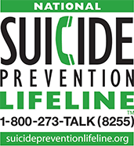
APPENDIX B

The National Suicide Prevention Lifeline (NSPL) is a national network of local crisis centers that provides free and confidential emotional support to people in suicidal crisis or emotional distress 24 hours a day, 7 days a week. NSPL is committed to improving crisis services and advancing suicide prevention by empowering individuals, advancing professional best practices, and building awareness.

APPENDIX C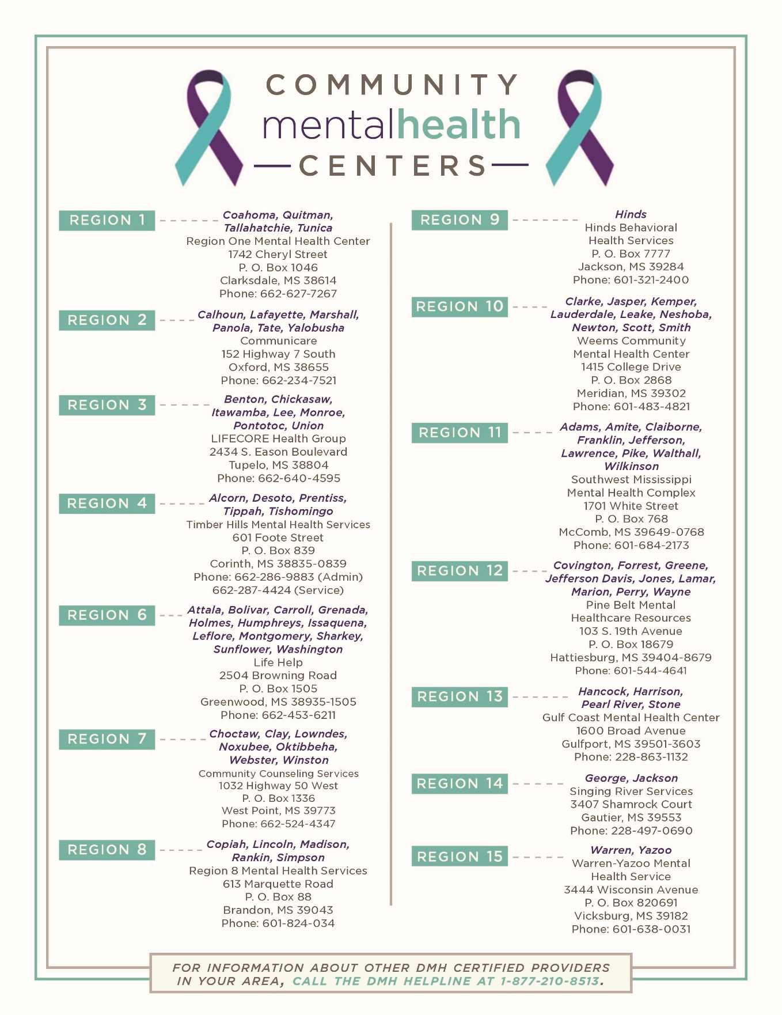
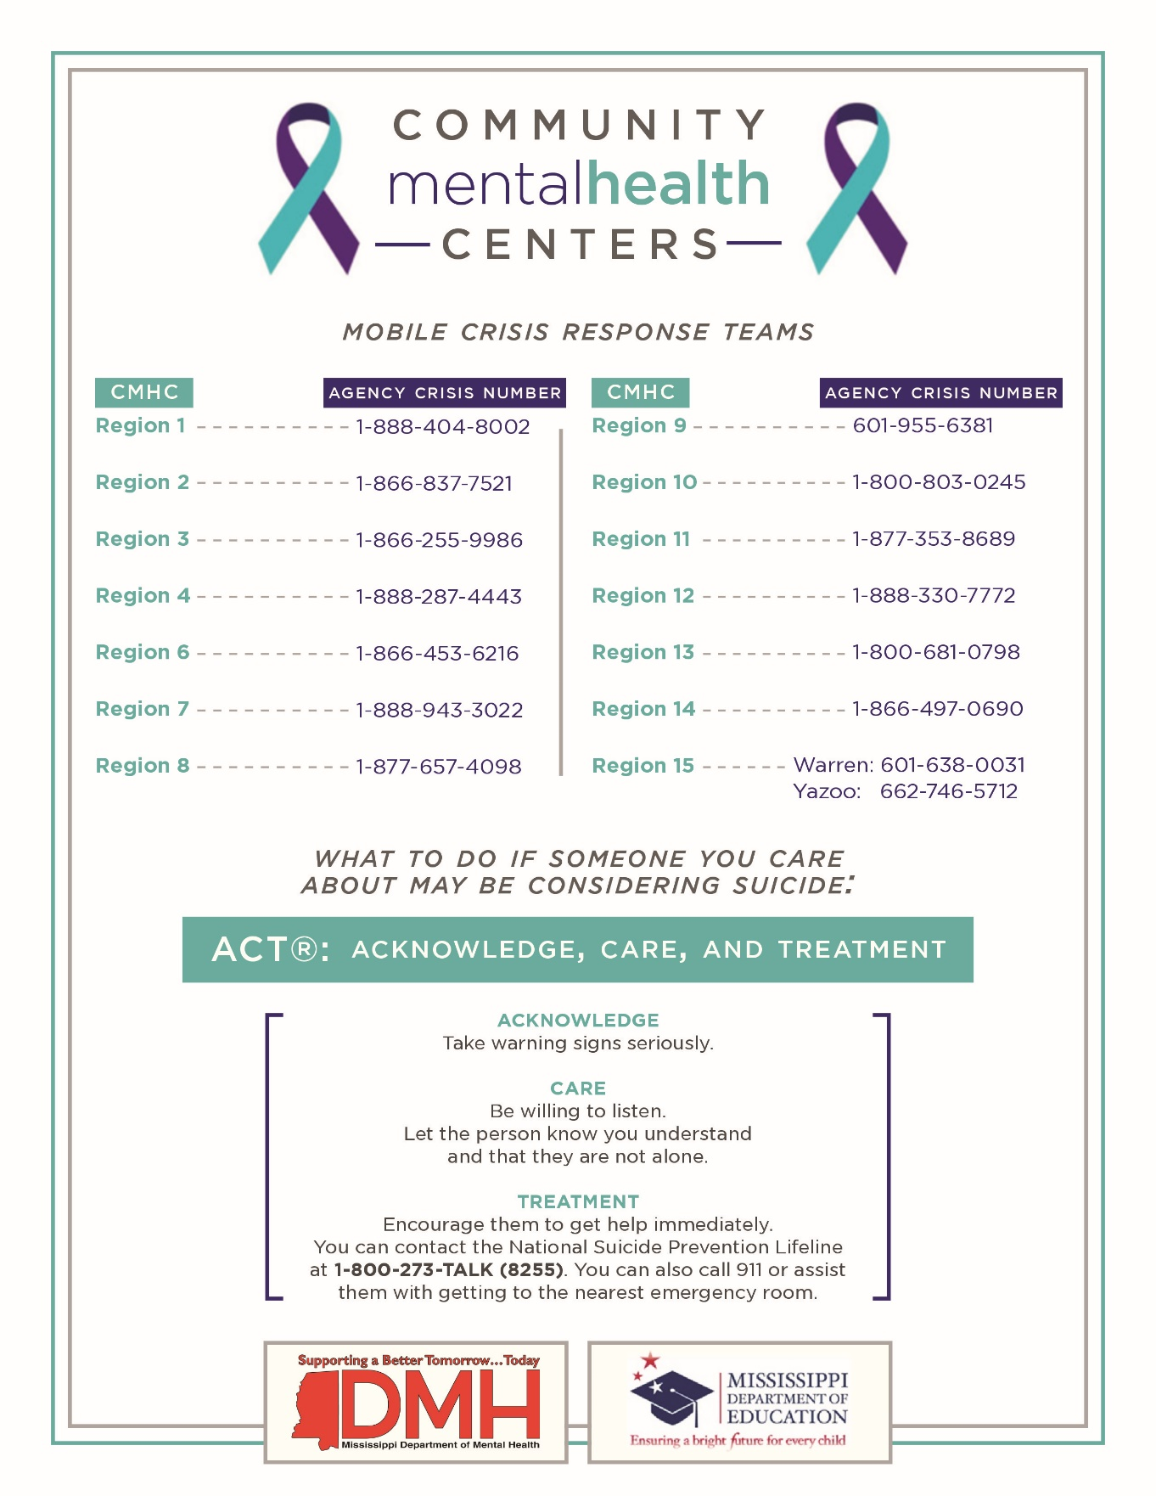
APPENDIX D
POLICY AS SUMMARIZED IN STUDENT & STAFF HANDBOOKS
Protecting the health and well-being of all students is of utmost importance to Western Line School District. The Western Line School District board has adopted a suicide prevention policy which will help protect all students through the following steps:
1. Students will learn about recognizing and responding to warning signs of suicide in friends using coping skills, using support systems, and seeking help for themselves and friends. This will occur in all health classes.
2. Western Line School District will designate a suicide prevention coordinator to serve as a point of contact for students in crisis and to refer students to appropriate resources.
3. When a student is identified as being at risk, they will be assessed by a school employed mental health professional who will work with the student and help connect them to appropriate resources.
4. Students will have access to national resources which they can contact for additional support such as:
- The National Suicide Prevention Lifeline—1-800-273-8255 (TALK), www.suicidepreventionlifeline.org

5. All students will be expected to help create a school culture of respect and support in which students feel comfortable seeking help for themselves or friends. Students are encouraged to tell any staff member if they, or a friend, are feeling suicidal or in need of help.
6. Students should also know that because of the life or death nature of these matters, confidentiality or privacy concerns are secondary to seeking help for students in crisis.
7. For a more detailed review of policy changes, please see the district’s full suicide prevention policy at www.westernline.org.

APPENDIX E
Suicide Prevention Training Implementation Guidelines

In 2017, the Mississippi Legislature passed House Bill 263 that requires all school district employees be trained in suicide prevention in the 2017-2018 school year, and new employees annually thereafter. The Mississippi Department of Mental Health and the Department of Education conducted a focus group meeting with teachers, school district administrators, mental health professionals, and family members of people who have died by suicide.

Based on the focus group’s input and recommendations, 2 online professional development series where chosen. They are:

- The Jason Foundation: Youth Suicide -- A Silent Epidemic (recommended for Classified Staff)

- Society for the Prevention of Teen Suicide: Making Educators Partners in Youth Suicide Prevention—Act on Facts (recommended for Certified Staff)

An additional evidence-based program, More Than Sad from The American Foundation for Suicide Prevention, is also available.

Below, you will find instructions on how to access the chosen curriculums:

The Jason Foundation http://jasonfoundation.com/
Youth Suicide: "A Silent Epidemic" (Module 5)

1. Go to “Get Involved”
2. Choose Educator, Youth Worker, Coach
3. Choose Professional Development Series
4. Choose Mississippi under “State” drop down menu
5. View Courses
6. Register
7. Choose Module 5- Youth Suicide: A Silent Epidemic

Society for the Prevention of Teen Suicide http://www.sptsusa.org/
2017-18 National Version - Making Educators Partners In Youth Suicide Prevention: Act On Facts
1. Go to the Educators tab
2. Choose Online Training
3. Left side of page under “Login” choose “Create New Account”
4. Choose Courses
5. Choose 2017-18 National Version - Making Educators Partners in Youth Suicide
Prevention: ACT on FACTS

Both professional development series are flexible in their implementation. School districts have a choice to allow each staff member to take the trainings individually, or to conduct the trainings in a group setting. Wi-Fi internet connection is not recommended due to buffering of video content.

Once staff members have completed the trainings, certificates are available to be printed that will show proof of completion. MDE will monitor school districts to ensure all staff complete the training.

Mental Health Resources

Counseling / Various Psychological Services:

Community Counseling
662.332.1819 Greenville

Leland Medical Clinic
662.686.4121 Leland

Life Help
662.335.5274 Greenville

Mississippi Behavioral Health Services
662.702.5108 Greenville

Intensive Counseling / Psychological Services:

MyPac – Mississippi Youth Villages
662.459.2240 Greenwood

Canopy – Mississippi Children's Services
800.388.6247 Greenville

