PHS Library Choice Board- Week Two
Choice #1 – Read a book! | Create a new ending to one of your favorite books.
Choice #2 – Explore one or more of our online resources. | Visit Mrs. Hill’s library site and explore one or more of the sites listed on the website page.  Mrs. Hill's Library Website  https://sites.google.com/ccschools.k12tn.net/khill/websites
Choice #3- Create a new character | Think of your favorite book. How would the story change if you added an additional character? Illustrate a picture of the new character that you created.
Choice #4-Write a letter | Write a letter to your future self about how you feel right now with missing school and having to stay home.
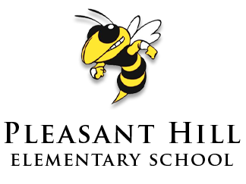
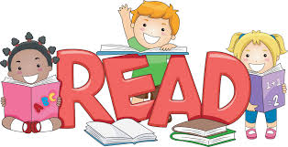
Please select at least one of these (hopefully fun!) activities to complete. Please email me if you
Have questions or just want to say hi!
hillk8@ccschools.k12tn.net

