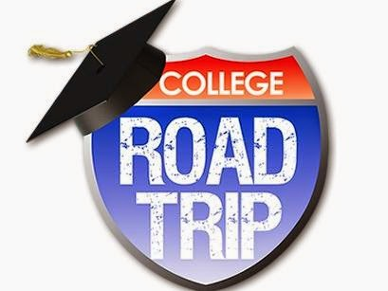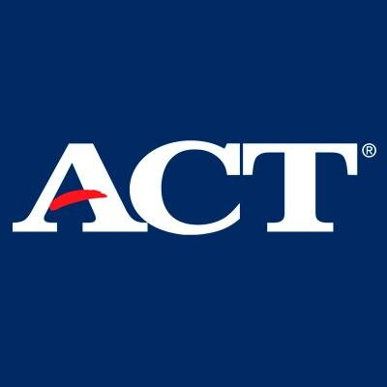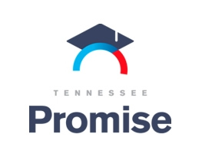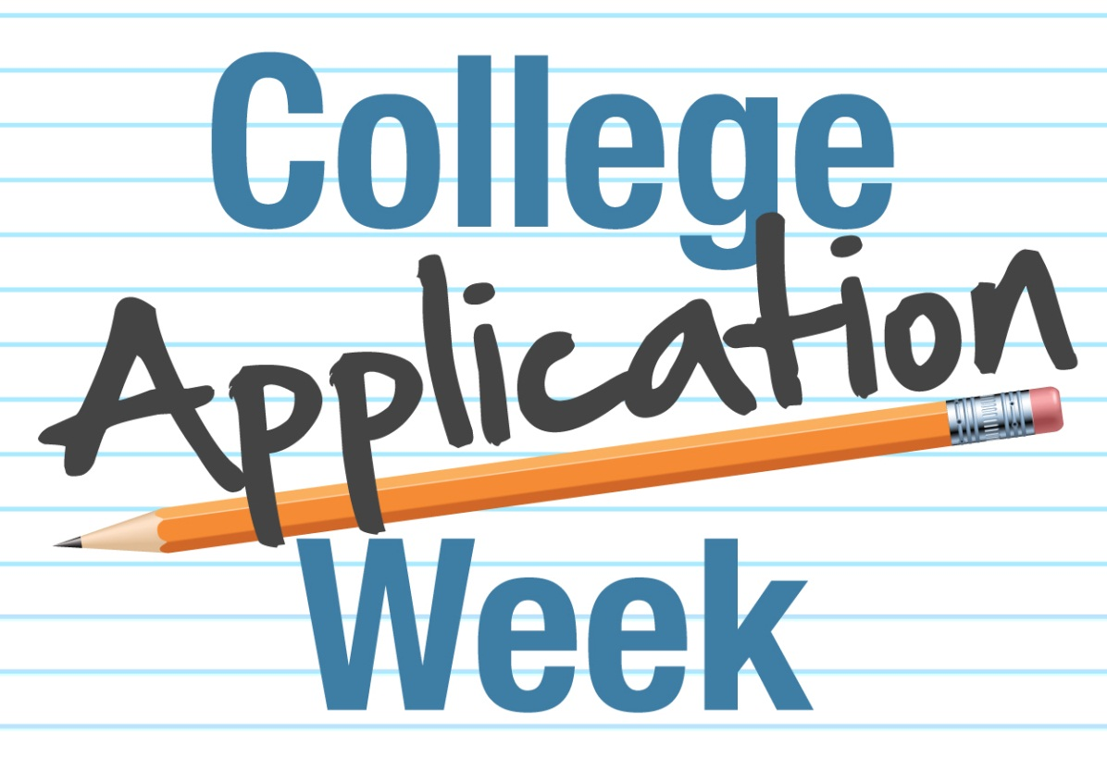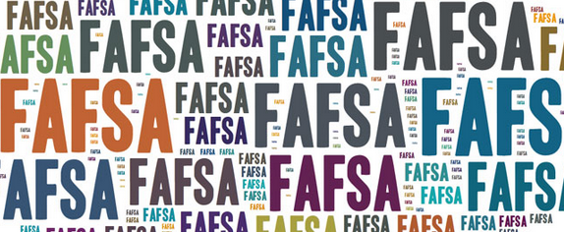

Welcome Back to BCHS! We are off to a quick start to the school year with a new schedule, new classes, and new staff. Seniors will quickly jump into transition planning for after graduation. Whether their choice is college, career training, military, or work BCHS staff are here to assist the student be ready for that next step. Newsletters will be sent periodically throughout the school year to update students, parents, and faculty to upcoming events and deadlines. Feel free to contact the School Counseling Office with any questions or concerns about your student.

Cyndi Johnson, School Counselor

All seniors must pick up a college visit request from a week prior to the visit in order to ensure approval of the date and so the visit will not count as an absence. The forms can be picked up from Mrs. Johnson.

## TNPROMISE application is Open

The TN Promise Application is now open for all seniors. To apply, visit TNPROMISE.GOV. The application will be available until **November 1.** There are no extensions of this deadline so do it today before you forget.

WELCOME

## College Visits

## ACT FREE

## RETAKE

2

1

3

For the first time, seniors in TN who took the ACT as a Junior will be able to retake the ACT for FREE. The test will be on **October 22** at any National Testing Location. Seniors must pick up the payment voucher from Mrs. Johnson and register online by **September 16**.

Issue: 1 9/01/2016

Counselor Notes

# **Dates to Remember**

**September 1** – Governor’s School Applications open for Sophomores and Juniors

**September 16** – Registration deadline for seniors to take the October 22 ACT exam (don’t forget to pick up your voucher)

**September 26 – 30** – College App Week

**October 1** – FAFSA Opens

**October 1** – College Goal TN Conference

UTC

**October 3** – FAFSA Frenzy

**October 13** – College Fair @ BCHS

**October 27** – FAFSA Frenzy

**November 1** – UTK Priority Deadline

**November 15** –FAFSA Frenzy

**December 1** – UTC Priority Deadline

MTSU Priority Deadline

**December 15** – TN Tech Priority Deadline

**January 17** – FAFSA Deadline

**February 15** – Chatt State Priority Deadline

#### FAFSA Frenzy in October

All seniors need to complete the FAFSA in order to receive any state or federal financial aid for college or technical schools. This includes the Hope Scholarship, TN Promise, Wilder-Naifeh Grant, and Pell Grants.

The application becomes available on October 1. Several dates have been schedule at BCHS to assist students and their families in completing the FAFSA. The application must be completed by January 17 for TN Promise and other State monies.

Information needed to complete the FAFSA:

Parent and Student SSN, DOB, Address

2015 Tax Information

Parent Marriage and/or Divorce Dates if applicable

FAFSA Frenzy Dates

October 3 October 27 November 15

College App Week

BCHS will host College App Week September 26 – 30. Assistance will be available that week from staff and area college reps to assist students in applying for college.