Amelia Love Johnson High School
New Students Registration Forms

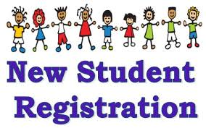
Contact School Counselor
Ms. Alexis Lewis
Phone: 334-627-3364
Email: alexislewis@marengo.k12.al.us
Contact School Principal
Mr. William Martin Jr.
Phone: 334-627-3364
Email: wmartin@marengo.k12.al.us

All Forms must be printed and filled out.
Email all forms back to counselor
With social security card and birth certificate

If you have any questions please contact the school counselor or principal.

