**What are we learning?**

**We want to keep things as simple as possible for all students. We have created the 3 R’s. This is what your child with internet at home can do every day.**

**3 R’s: Read/Reflex/ReadingEggspress**

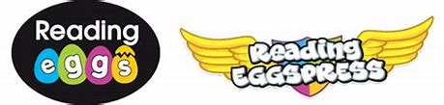

Reading Eggspress. This week we have books for you to read and online quizzes to complete.

Fiction Book: Crocodile in the Kitchen

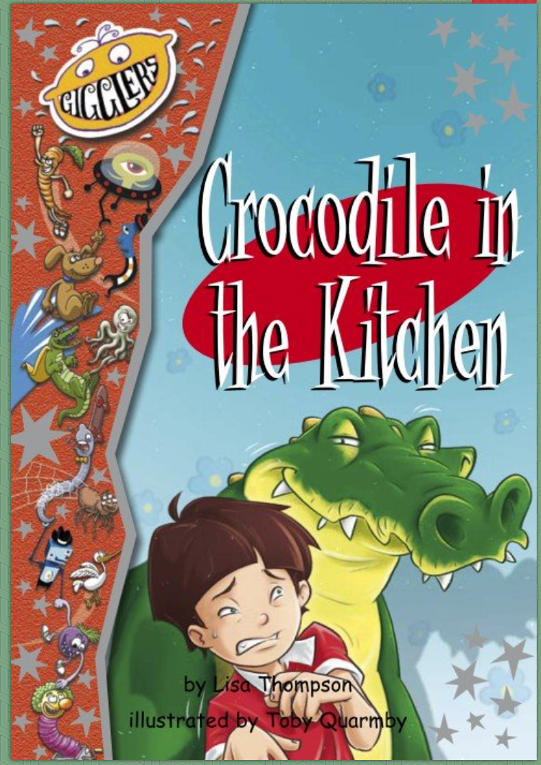

Non-Fiction Book: Reptiles

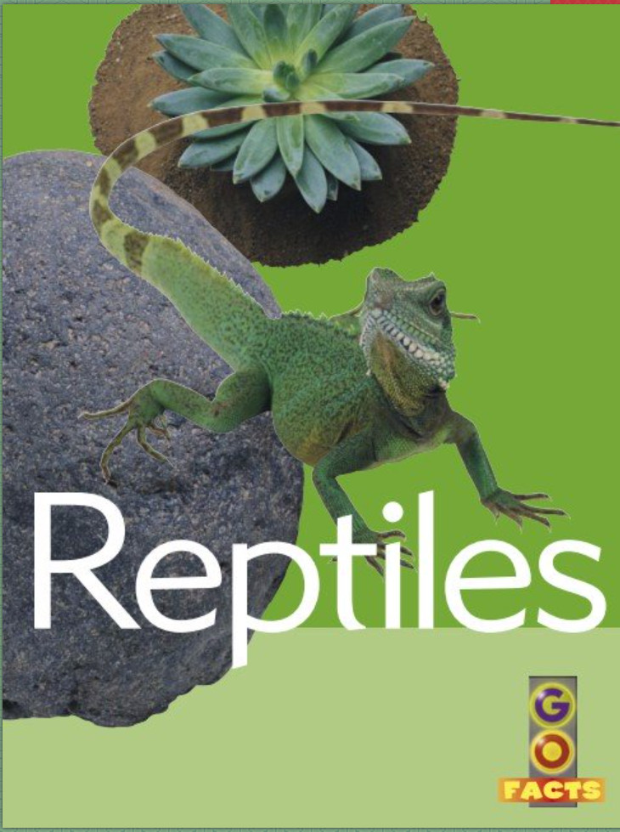

### DCPS

April 13th- 17th

2nd Grade News

**Math Skills**

😊Did you get a green light on Reflex today?

This week your teacher will post on their website:

* Word Problem of the Day
* 9 Box Review

Remember you can do this on notebook paper too.

**Comprehension Questions Parents Can Ask:**

1. **How would you feel if you saw a giant crocodile in your kitchen?**
2. **If you could change the title, what would it be?**

**Comprehension Questions Parents Can Ask:**

1. **Name three interesting facts that you learned.**
2. **What is your favorite reptile after reading this book?**

Videos for kids:

<https://kids.nationalgeographic.com/animals/reptiles> (National Geographic)

<https://youtu.be/pQSdHBusHpE> (Homeschool Pop)

<https://youtu.be/6CQHewteFo8> (Reptile Song by Have Fun Teaching)

**Remember me**

**Please remember these are only suggestions to help maintain information that was previously taught in class. Your child can always choose a different book or activity from home to complete.**

**Website/Facebook:**

Please look at your teacher’s website for more links and information. We have also created a DCPS 2nd Grade Facebook group that you can follow for more ideas and websites.

Writing Prompt

Choose one of the following reptiles- a snake, lizard, or turtle.

Pretend that reptile has come to live with you. How would you take care of it? What would it eat? Where would you keep it? Write a paragraph telling about your reptile.

## Phonics