CASTLEN ELEMENTARY SCHOOL
Third Grade School Supply List
2020-2021
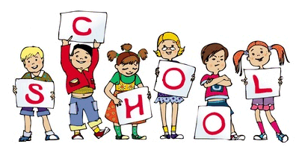
Central Office is requesting that parents provide a face mask for their child to have with them at school each day. Cloth is preferred due to durability.
24 pack of pencils
1 pack of Expo markers
1 box of crayons or colored pencils
1 pair of scissors
1 school supply box
1 pack of highlighters
2 glue sticks
3 packs of wide ruled lined paper
2 composition notebooks
1 spiral notebook
6 plastic folders with prongs (one red)

WISH LIST
Hand Sanitizer
Paper Towels
Kleenex
Ziploc bags-quart or gallon size
Clorox or Lysol wipes

