Everything that has been suggested on here can be found on my webpage. If you need the work and cannot get to my webpage text me your email and I will be happy to email everything to you. Happy learning!!!

Morning routine: Reading and Phonics
- 20 mins of Istation Reading
- 10 mins homework sheets- Monday and Tuesday: this is phonics practice (some math)
- 5 mins read phonics poem (circle: sight words, rhyming words, letters, sounds)
- 20 mins reading leveled books (use We finished a book! What might we talk about grid)
- 5-10 min sight word practice (sentence building, writing, idenitifying)
- 5-10 storyland board game. (roll die, land on a square, start telling the story using what is in the square, continue the story as you roll the die and land on a square)

Afternoon: Math and Writing
- 20 mins of Istation Math
- 10 mins homework sheets- Wednesday and Thursday: this is phonics practice (some math)
- 5 mins math fact practice (cut cards to practice)
- 10 min word problems
- 20 mins of writing: drawings with labels and a sentence (the writing may take a couple of days to complete)
- a story (something I have done)
- non-fiction (draw and tell about something you know… like frogs)
- Fun activity that teacher or mom found (making playdough, slime, moon sand, etc)

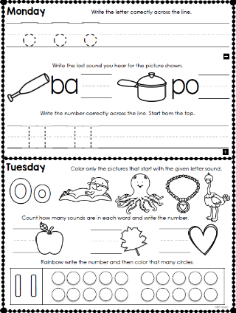
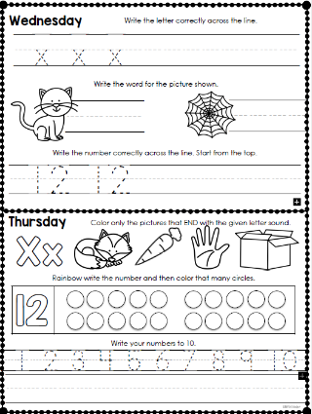
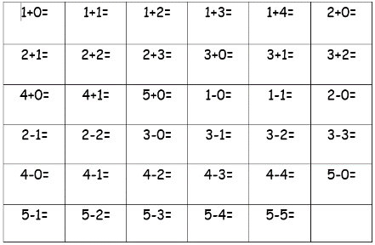
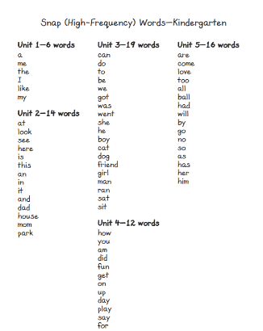
Examples of work:

