RIF's Printable Parent Guides
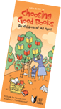
Reading Is Fundamental has developed these brochures on a variety of topics to help promote the habit of reading in families.
Download, print, copy and distribute any or all of these materials for free!
http://www.rif.org/parents/resources/parentguide.mspx

You can also sign up for RIF's free eNewsletter.

