Teacher Contact Information:

Todd Beaver

Email: todd.beaver@chestercountyschools.org
Room: w9

Course Description:
Geometry emphasizes similarity, trigonometry, congruence, and modeling geometry concepts in real life situations. Students build upon previous knowledge of similarity, congruence, and triangles to prove theorems and reason mathematically. This course also introduces students to geometric constructions and circles. Students show a progression of mastery and understanding of the use and application of surface area and volume.

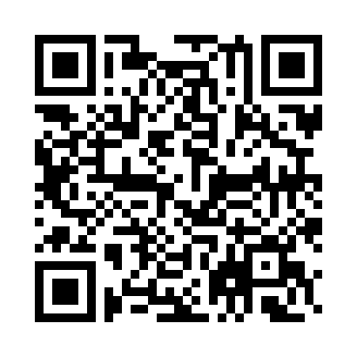
Standards Covered:
We will be covering the Tennessee’s State Mathematics Standards for Geometry. These are available from the Tennessee Department of Education website or by scanning the QR code.

https://www.tn.gov/assets/entities/education/attachments/std_math_geometry.pdf

Topics:
- Midpoint, Endpoint, Distance
- Proofs
- Segment and Angle addition Postulates
- Parallel and Transversal lines
- Triangles
- Pythagorean Theorem
- Geometric Mean
- Special Right Triangles
- Trigonometry
- Ratios, Law of Sines, & Law of Cosines
- Angle Relationships
- Constructions

- Points of Concurrency
- Congruent Triangles
- Similar Polygons
- Circles
- Arcs and Chords
- Sector Area and Arc Length
- Parallelograms
- Area of Regular Polygons
- Surface Area and Volume
- Prisms, Cones, Cylinders, Pyramids, & Spheres
- Transformations

Grading Scale (School-Wide):

Report card letter grades reflect a percentage of those scores using the following grading scale:
A = 93 - 100
B = 85 - 92
C = 75 - 84
D = 70 - 74
F = 0 – 69

Each student’s grade will be calculated using the following percentages:
Assessments: 70% Quizzes 20% Assignments 10 %

Major Assessments:
Students have a comprehensive test at the end of each week. Squares tests will be administered every Thursday until Christmas. Formula tests will be administered every Thursday from January until the conclusion of the school year. Students will also be taking the TNReady test at the conclusion of the school year. It should also be noted that Geometry composes roughly 40% of the ACT which students complete during their junior year.

Resources:

Test Solutions
Videos of weekly test solutions will be uploaded to google classroom 1m8ffv6 to assist students in correcting any mistakes they’ve made in order to decrease the likelihood of their making the same mistakes on subsequent tests. Google classrooms 3lnqzwu and z3hs6f are from the two previous years and contain all the tests that were taken as well as solutions videos. These classrooms essentially make it possible for a student to self teach everything they’re about to learn this year.

Geometry, Carnegie Learning 3rd Edition
Students have consumable textbooks available upon request.

Supplies:
- Ruler (inches and centimeters)
- Compass
- Graph paper
- Pencil
- Notebook
- Calculator (Students will have access to a TI-nspire calculator to use while in class, however, due to the nature of this specific course, it is recommended that each student purchase a TI30XII calculator as these are very inexpensive ($8.88 Walmart) and far quicker and easier to manipulate than the Inspire.)

Tutoring:

Tutoring has typically been made available twice weekly after school in the cafeteria. Also, I will personally be available most mornings from 7:30-7:50 to give additional support.

Cell phone policy: Cell phones will be confiscated if they are seen or heard.

