|  |
| --- |
|  |
| Junior/Senior News~ September 2019 |
|  |

Marbury High School



|  |
| --- |
|  |
| Important Upcoming Dates: **College and Career Night**  **Monday, September 16, 2019**  **6-8pm**  **Montgomery Multiplex @**  **Cramton Bowl**  **Register to win:**  **$1,500 in Scholarships**  **College 101/Scholarship Information Night**  **September 9, 2019**  **6pm**  **MHS Cafeteria**  **Bring Your PARENT with YOU!!!**    **Birmingham National College Fair**  **September 15, 2019**  **1-4pm**  **Birmingham-Jefferson**  **Convention Complex**    **Colleges Visiting MHS!!!!**  **AUM- Tuesday, Sept. 3rd**  **UAH- Thursday, Sept 5th**  **Faulkner – Wednesday, Sept. 25th**  **JSU- Thursday, Sept. 26th**  **When: College Application Week :**  **October 29-November 2, 2018**  **Where: Library with Career Coach- Ms. Hedgspeth**  **When: During Coach Brothers’ Classes** |
|  |

|  |
| --- |
|  |
| Dear Senior,  Not sure what you want to do with your life? Why not take a look back at your Kuder Career Interest Inventory that you completed a few years ago?  <https://al.kuder.com> |
|  |



**IMPORTANT!!!!!!!!!**

## Autauga County College and Career Fair

## September 16th @ 8 am

## Cost: $1

## Permission Slip/Money Due: Friday, Sept. 6th

***Students need to create a personal barcode at*** [***http://www.gotocollegefairs.com/***](http://www.gotocollegefairs.com/)

**Helpful Websites:**

**https://www.scholarships.com/financial-aid/college-scholarships/scholarships-by-state/alabama-scholarships/**

**QUESTIONS TO ASK YOURSELF:**

1. **Have I registered and been practicing to retake the ACT?**
2. **Do I know where I want to attend college or technical school?**
3. **Have I started researching the schools that I am interested in attending?**
4. **Have I visited any university/college campuses yet?**

Important Things to Remember While Planning for College

## Applications for college admissions are available now.

## December 1st is the deadline for most major university scholarships in the state of Alabama.

## Some university/ colleges have the same application for both admissions and scholarships.

## Once application process has been completed, request high school transcript through Parchment.com

## FAFSA opens October 1st. Most colleges require FAFSA completion.

## PLAN, PLAN, PLAN!!!!

## 

|  |
| --- |
|  |
| ACT/SAT Updates!!!!!! |
|  |

ACT Cost: No writing- $46.00

With Writing- $62.50

SAT Cost: No writing - $49.50

With Writing- $64.50

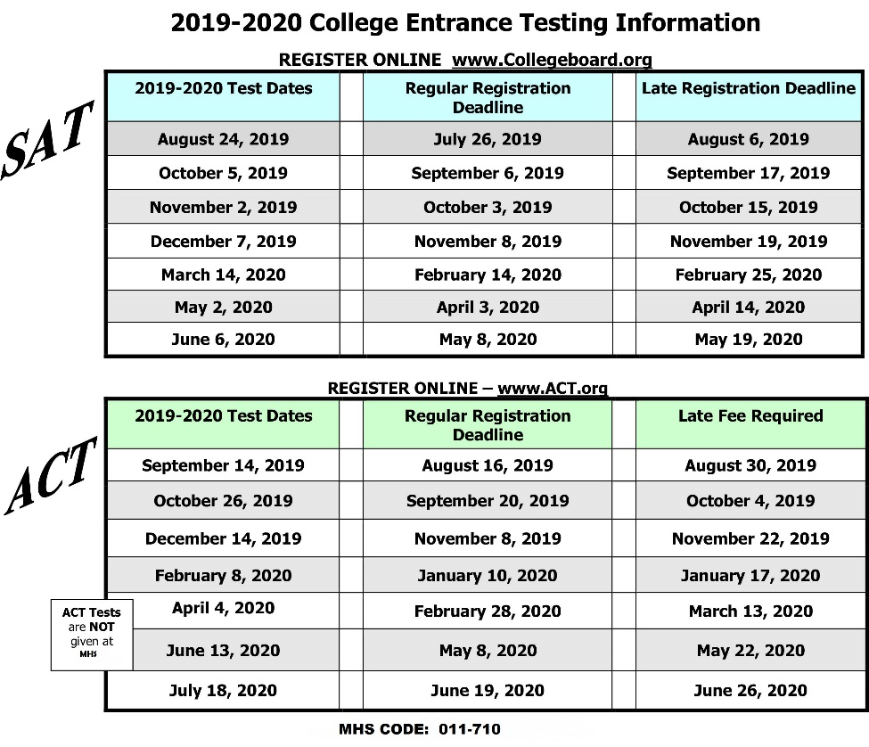

***\*\*\*\* If you receive free/reduced lunch, see Mrs. Hicks for a fee waiver.***

Ordering Transcripts

*Go to Parchment.com, click Sign up and follow the onscreen instructions to register

*Click Transcripts

*Find your high school, select it and click Save & Continue

* Sign the Transcript Request Form

*Select the Destination of the transcript

*Enter your payment details and click Submit.