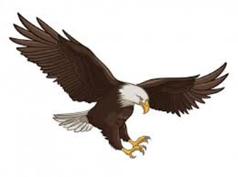
Shirts (no handwritten words or symbols):
• Polo/Golf style with buttons or school T-shirts, color must be
Maroon, Gray, White. All shirts will be tucked in.
Undershirts must be school colors: ALJ: white, maroon, or gray (no visible writing).
• All shirts with buttons must be buttoned with the exception of the top neck button. No revealing tank, halter, crop or other garments should be visible. Shirts should not be excessively tight.

Pants/skirts/shorts (no handwritten words or symbols):
Colors: Black & Khaki Pants (No Jeans) Pants must have belt loops and belts.
Boys and girls may wear khaki long or short pants that come to the top of the knee. Girls may wear khaki capri pants, jumpers or skirts that cover the knee. No Jeggings & No Joggers

Shoes (no handwritten words or symbols):
• Any color shoes may be worn. All shoes must be closed in the front and back. Shoes are to be tied, buckled and/or secured. No lighted shoes are allowed. Pants should not be tucked into socks, shoes or boots.
Socks:
Black, maroon, gray, or white socks only.

Belts:
Brown, black, or khaki belts will be required on pants with belt loops. Belts and buckles must be plain. Large buckles or marquee buckles are prohibited. Belts must be worn daily!

Outerwear:
All outerwear will be purchased from the school to provide families with economical outerwear choices as available. Students may purchase the following from the school in school colors:
• Fleece pullovers. • Sweatshirts • School Issued Coats
Students may also wear letterman jackets or cheerleader jackets that they have purchased through the school. Scarves worn should be school colors. Students may wear heavy outerwear when the temperature falls below 45 degrees

Head coverings (no handwritten words or symbols):
• Hats, caps, sunglasses, bandanas, and other head coverings are not part of the school uniform and are not allowed at school. Cold weather hats, earmuffs, or ear warmers must be removed before entering the buildings. This applies to both girls and boys.
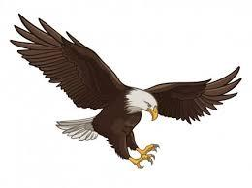
Jewelry:
If necklaces are worn, they are to be inside of the shirt at all times.
Headbands, bows, etc. should be school colors.

Prohibited (PreK – 12)
• Pants worn below the waist or oversized uniforms.
• Overalls.
• Pants with zippers or laces on the side or legs.
• Anything hanging out of pockets.
• Skinny jeans or khakis, leggings, jeggings, pants with elastic at the bottom.
• Excessively tight pants.
• Hoodies.
• Boys may not wear two earring in their ear.
•Hair should be clean, well groomed, and should be groomed so that it does not cover the eyes and face.
• Student attire that is a distraction to learning is prohibited.
• Students who transfer from other school districts will be given a period of five (5) school days to comply with the dress code

