Holly Springs School District’s
ACCEPTABLE USE AND INTERNET SAFETY POLICY FOR STUDENTS
PURPOSE:
Holly Springs School District provides all students access to the Internet, and also in some cases laptop computers, iPad, iPods, as a means to enhance their education. The purpose of this policy is to assure that students recognize the limitations that the school imposes on their use of these resources. In addition to this policy, the use of any school computers, including laptop computers, iPads, iPods, Smartphones, iPhones, or any other school device that may be connected through Holly Springs School District’s network to the Internet also requires students to abide by the Holly Springs School District Computer use Guidelines. During the course of the school year, additional rules regarding Internet safety may be added. If this occurs, any new rule will become a part of this policy.

TERMS OF THE ACCEPTABLE USE AND INTERNET SAFETY POLICY
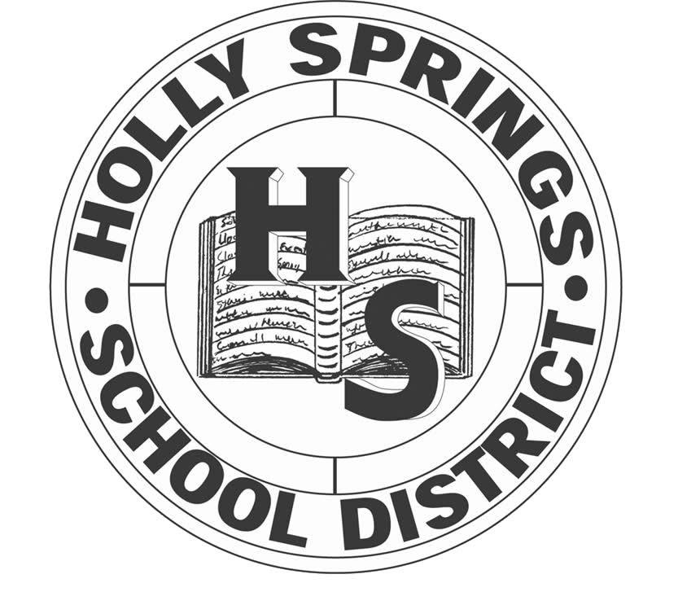Specifically, the student:
Should use the resources available through the Internet and other electronic media to supplement material available through the classroom, media center or through any other resource provided by the school.

Should adhere to guidelines each time the Internet is used at home and school.
Should make available for inspection by an administrator or teacher upon request any messages or files sent or received at any Internet location.

Should use appropriate language in all communications. The student should not use profanity or obscenity and should avoid offensive or inflammatory speech. The student should not participate in “Cyber Bullying” such as personal attacks and/or threats on/against anyone using these resources. The student should report to responsible school personnel any personal electronically transmitted attacks in any form made by others over the Internet or Local Area Network (LAN) observed while using school-owned technology.
Should abide by copyright laws and should only download/import music or other files to a school-owned computer, including laptop, that he/she is authorized or legally permitted to reproduce, or for which he/she has the copyright.
Should use his or her real name in all educational activities that incorporate technology or the Internet (e.g., distance learning, online distance learning, etc.).
Should respect the privacy of others. The student should re-post (to make appear online again) communications only after obtaining the original author’s prior consent.
Should use technology for school-related purposes only during the instructional day.
Should not make use of material (files) or attempt to locate material (files) that are unacceptable in a school setting. This includes, but is not limited to, pornographic, obscene, graphically violent, or vulgar images, sounds, music, language, video or other materials (files). The criteria for acceptability is demonstrated in the types of material made available to students by administrators, teachers, and the school media center. Specifically, all school owned computers should be free at all times of any pornographic, obscene, graphically violent, or vulgar images, sounds, music, language, video or other materials (files).
Should not access or attempt to access instant messages, chat rooms, forums, e-mail, message boards, or host personal web pages, except school approved, teacher-supervised filtered Internet communication, during the instructional day.
Should not attempt to discover passwords or to control access to the Internet or the computer network.
Should not change or attempt to change the configuration of the software that controls access to the Internet or any other electronic media.
Should not download any programs, files, or games from the Internet or other sources that can be run or launched on the computer as a stand-alone program. These programs or files are sometimes called “executable files.”
Should not use this resource for any illegal activity. This includes, but is not limited to, tampering with computer hardware or software, unauthorized entry into computers, and vandalism or destruction of computer files.
Should not knowingly introduce or knowingly allow the introduction of any computer virus to any HSSD computer.
Should not connect a personal, non-school-district-owned desktop computer, laptop computer, wireless personal digital assistant (PDA), or any other network (wireless or directly plugged) device to any part of the HSSD network (local area network “LAN,” wide area network “WAN,” or metropolitan area network “MAN”).
Should not share passwords with anyone for any reason and should make every effort to keep all passwords secure and private.
Should not play games, including Internet-based games, except school-approved, teacher-supervised educational games, during the instructional day.
Should not download, upload, import or view files or websites that purport the use of illegal drugs, alcohol or illegal and/or violent behavior except school-approved, teacher-supervised digital media.
Should not bypass or attempt to bypass HSSD filtering software.
Should not access or attempt to access any prohibited sites, such as myspace.com, facebook.com or similarities.

Should not use the network system for soliciting or distributing information with the intent to harass, intimidate, or bully which can be described as Cyber Bullying.

Students should not post chain letters or engage in “spamming” (that is sending an annoying or unnecessary message to multiple recipients).

I have read the Acceptable Use Policy. If my child follows the rules he or she may keep access to the network. If he or she does not follow the rules in the Student Acceptable Use Policy, I understand that my child’s network access will be suspended and or other disciplinary actions.
The specifications of the Acceptable Use policy will include the education of minors about appropriate online behavior, including interacting with other individuals on social networking sites and in chat rooms, and Cyberbulling awareness and response.
Student Name: ________________________________________________________Grade:____________

Parent/Guardian Signature: _____________________________________________Date: _____________

Parent/Guardian Signature: _____________________________________________Date: _____________

Parent/Guardian Signature: _____________________________________________Date: _____________

Email: _______________________________________ __________Relationship to Student______________

Email: _______________________________________ __________Relationship to Student______________
Updated: April 25, 2012

