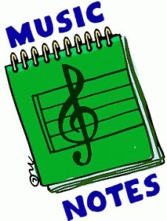
Week of:
APR. 20-Apr. 24
4/20: Our integrity word this week is Zeal! If you have zeal for something, then you are REALLY EXCITED to do it and nothing can hold you back or stop you from doing it. So, this week see if you can keep the beat with our integrity song of the week, “There’s nothing holding me back”
4/21: Watch “Over in the Meadow”
4/22: Let’s dance to “The Crocodile Rock” with the Just Dance 2 kids
4/23: Let’s play “Bean Bag Fun” with a Ziploc bag of rice
4/24: Let’s Dance and Sing to our fun song Friday tune, “High Hopes” from the new Netflix movie “Trolls World Tour” that came out April 10. Check it out!

