

Reminders

-**Masks** need to be worn at school.

-October 5: Bullying Awareness day **(wear blue)**

-October 12: Columbus Day (no school)

-October 13-16: PTO selling Boo Grams

-October 16: Honor Roll Breakfast

-October 19-23 Homecoming Week

**Mon: pajama day**

**Tues: old folks day**

**Wed: camo day**

**Thurs: “Out of this world day”**

**Fri: Mustang spirit day**

-Oct. 21: National Bullying Prevention day **(wear orange)**

-October 26-30: Red Ribbon Week

**Mon: team jersey day**

**Tues: pajama day**

**Wed: Hawaiian day**

**Thurs: Western day**

**Fri: Book character day**

-Dismissing Every Friday at 1:10

October 5th – 9th

Homework

Monday:

* Traditional 2 by 2 digit multiplication worksheet
* Study math facts

Tuesday:

* Traditional 2 by 2 digit multiplication worksheet
* Study math facts

Wednesday:

* Traditional 2 by 2 digit multiplication worksheet

Thursday:

* Traditional 2 by 2 digit multiplication worksheet

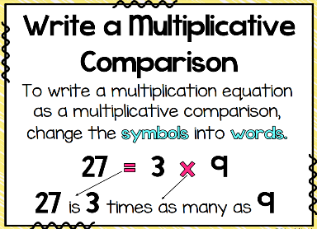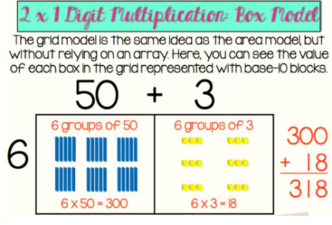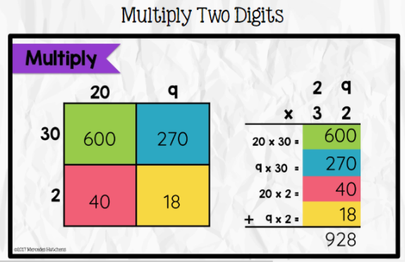

What we are learning…

Tests/Projects

-3 by 1 multiplication quiz 10/7

-Timed Test 10/7

- 9 weeks review test 10/8