How To Log into Lock Down Browser on Chromebook
Step One: Without signing into the computer, they need to choose LockDown Browser from the Apps menu on the taskbar.
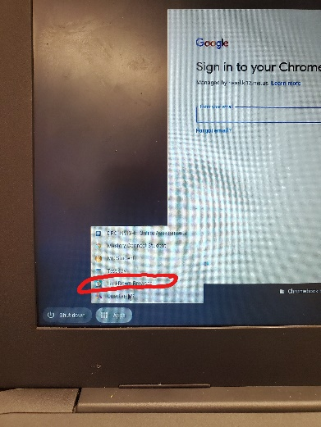

Step Two: It will ask to choose your Institution. type in “Holly Springs School District." The option will pop up, they'll click on it, then click "Select." This will only happen the first time. After that, this step will be skipped.

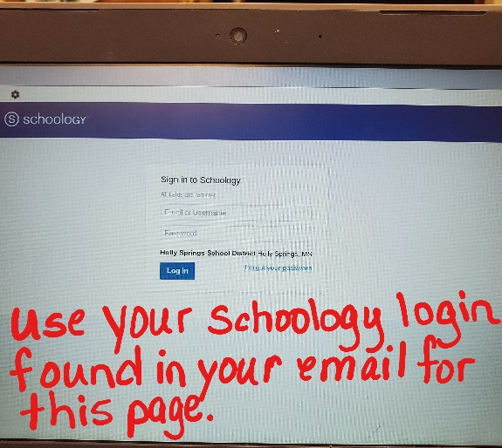
Step Three: The LockDown Browser will present the students with a Schoology Login screen. They'll log in to Schoology as they normally would.

Step Four: Navigate to the test and take it.

