QUEST First Grade Week 3
Day 1 - March 30
Reading and Science | Watch this Mystery Science (Mystery Doug!) video about unicorns: https://mysteryscience.com/mini-lessons/unicorns?code=1c33391421483694d6ab186c19eaca37  Then log on to myON (info below) and read a book about the unicorns of the sea.  Search for A Day in the Life: Polar Animals Narwhal  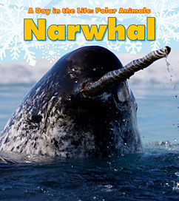  myON student login:  username: lunchnumber  password: lunchnumber  Listen to or read the story twice and take the AR test. Here is the link to Ithica’s AR: https://hosted181.renlearn.com/49884/  And here is the quiz number for this book: 144518  It’s a 2.6 level book so be sure you listen to the book at least two times so you can get a good score!  Optional: Draw a picture of a unicorn AND a narwhal and send it to me!

Day 2 - March 31
Science and Writing | Watch this video about narwhals to continue our study from yesterday:  https://www.youtube.com/watch?v=CJbmSsSxf_A  Then complete this circle map (draw it on a piece of paper and don’t worry about the Frame of Reference part.) Write FIVE things you’ve learned about narwhals inside the map and send it to me (example below).  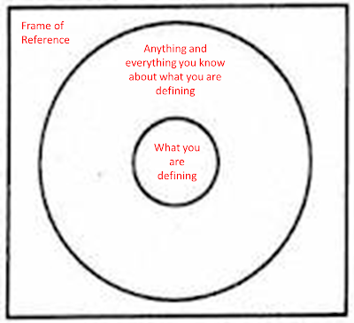

Day 3 - April 1
STEAM (art) | Watch this video about Michelangelo and the Sistine Chapel: https://www.youtube.com/watch?v=abW2kZ5_Eww  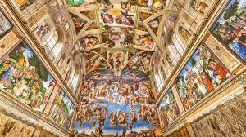  Today, you are going to experiment being Michelangelo and create your OWN masterpiece.  The video said that you were to paint something that happened from your summer but you can paint or draw ANYTHING. Follow the steps:  - Tape a piece of paper under a table or desk.  - Get all your art supplies together (paint, markers, colored pencils, etc…)  - Paint or draw any picture you’d like but remember to cover the whole paper  - After your masterpiece is dry, take a picture of it and send it to me! Ciao, signores and signorinas!

Day 4 - April 2
Math | Visit this link to BrainpopJr.com to watch a video about money: https://jr.brainpop.com/math/money/dollarsandcents/  If you need to log in, here’s that info:  Username: ithica  Password: brainpop  Then take the easy quiz and email me your score.  Practice adding and sorting coins using one of these games. Your pick!  https://www.abcya.com/games/learning_coins  https://www.quia.com/mc/4918.html (this one is adding coin amounts)

Day 5 - April 3
Math | First, use this link to practice identifying coins with Boom Cards: http://boom.cards/fastplay/wqqc  Then get some coins from your mom or dad. Try to get at least 15 and make sure you have at least 1 of each type of coin. Sort them into a graph like one of these examples:  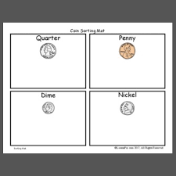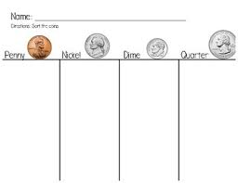  Email a picture of your coin sort to me at teri.donaldson@carrollcountyschools.com

