Mrs. Daniel’s Newsletter
February 8-12, 2021
Grammar (comparative – [-er] and superlative – [-est] adjectives),
Skills (fact and opinion), and Topic 9 Math Test: Thursday
Vocabulary and Spelling (ou, ow, oi, oy) Tests: Friday

Important Dates:
Friday 2/12- 100 Days of School, Valentine’s Day Celebration
Story:  “Soil”  by Sally M. Walker  Phonics/Fluency:  diphthongs  ou, ow, oi, oy  Text-Based Comprehension:  fact and opinion, questioning  Grammar:  comparative (-er) and superlative (-est)  adjectives |  | Selection Vocabulary Words (Students will be tested on these):  - texture – the feel that things have because of the way they are made  - substances – materials that something is made of  - materials – what things are made from or used for  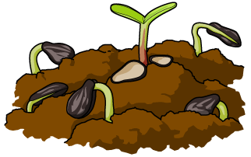  - grains – tiny bits of sand, sugar, or salt  - seeps – flows very slowly through something  - particles – very little pieces of something  Amazing Words  discovery, underneath, fine, landscape,  transform, blizzard, incredible, molten
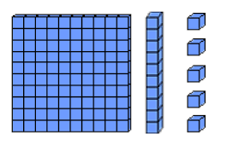  Math: Topic 9  Subtraction with Regrouping  This week, we will be reviewing  subtraction with regrouping.  Please make sure to complete  practice problems for homework for each night. |  |  | Social Studies/Science  We are learning that people have  different systems that perform  different functions. Some of these  include circulation, digestion, and respiration. We will study the parts of the body that are associated with these systems.
Spelling Words:
- around  - out  - gown | - sound  - flower  - howl |  |  | - toy  - noise  - royal | - moist  - coil  - cow

