What is Succession?
• Ecological Succession: the series of changes in an ecosystem when one community is replaced by another community as a result of changes in biotic and abiotic factors
• Can regenerate a damaged community • Can create a community in a previously
uninhabited area
• Occurs in all types of ecosystems (forests, ponds, coral reefs, etc)
Primary Succession
•Primary Succession: the process of creating and developing an ecosystem in an area that was previously uninhabited
• Examples of uninhabited areas: • Sides of volcanoes • Sites of glacier recession
• Occurs in areas with no soil
• Is a very slow process
• The process of primary succession starts with the arrival of living things such as lichens and mosses that do not need soil to survive
• These first species are called pioneer species
• Pioneer species: the first organisms to live in a previously uninhabited area
1. Pioneer species move into an unoccupied area
• The pioneer species help create soil by breaking down the rock particles into smaller and smaller pieces
• As lichen and mosses die, they decompose and add small amounts of nutrients to the rock particles, creating soil
• During this early stage of succession there are not many habitats so not many organisms are found in the environment
2. Once there is enough soil and nutrients, small plants such as flowers, ferns, and grasses grow
• These plants help to further break down the rocks and add nutrients to the soil when they die and decompose
3. The small plants create habitats for small animals like insects and small mammals
- Over time, as animals die and decompose, their bodies add nutrients to the soil allowing larger plant species to populate the area
- Larger animals follow the larger plants
• Eventually, a mature community is formed, this mature community is called a climax community
• A climax community is a community that is able to maintain itself for long periods of time with few changes in the species that populate it
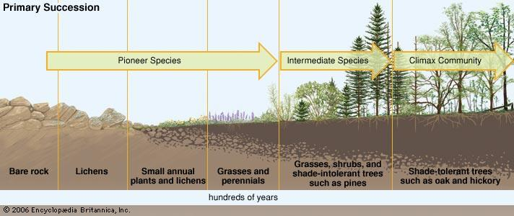
Secondary Succession
• Secondary Succession: the process of repairing a damaged ecosystem
• Occurs in areas where the soil was left intact
• Examples of events that damage ecosystems:
• Natural disasters • Human activities • Death of organisms
• Is typically a much faster process than primary succession because there is already soil
• Secondary succession is a never ending process
• Any disturbance in an ecosystem results in secondary succession starting over
• Looks very similar to primary succession but does not require soil forming pioneer species
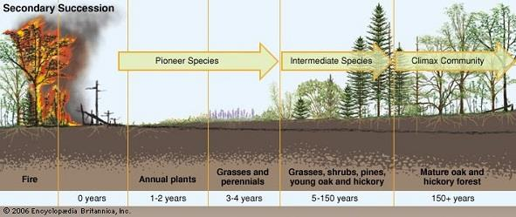
If an ecosystem is frequently disturbed it will not be able to support large ___________________ so it will consist of the ________________ typical of the ________ stages of succession

