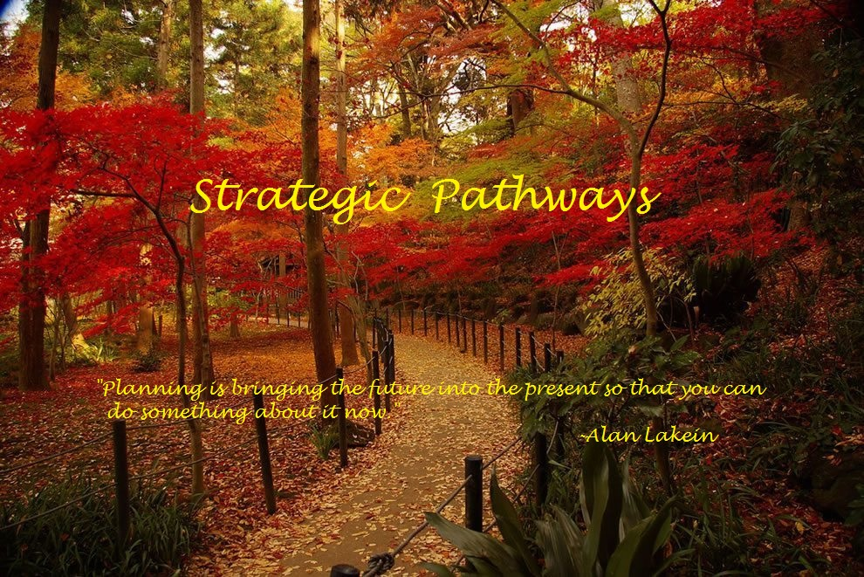

“Preparation for Progress”
Effective planning is far more than an abstract concept. It is actually a research-based strategic process leading to the deliberate organization of people and activities as well as the allocation of resources to accomplish a desired goal. Among numerous advantages, one of the most valuable outcomes of the strategic planning process is the efficient utilization of time, for both individual members and the collective organization. Given this premise, consider that research has demonstrated that for every minute dedicated to strategic planning, ten minutes can be gained in execution. If then, one minute of planning equates to ten minutes of execution, then ten minutes of planning should equate to one hour and forty minutes of execution. Consider then, if an individual or an organization could gain an additional thirty minutes of execution time per day, through effective strategic planning, that would equate to roughly twenty-two additional days of production available throughout the course of a year. Do the math and consider the benefit of those additional days, without additional personnel costs, and you would probably agree that is a pretty good return on anybody’s investment!
Strategic Pathways is a planning partnership that combines the deep and powerful experience and expertise of The Akribos Group, Dr. Faron Hollinger, President/CEO, and Education Solutions, Dr. Ruth Ash and Dr. Pat Hodge, founding partners. Strategic Pathways facilitates strategic planning that is research-based, engaging, forward thinking, and focused on results. Our collaborative processes help school districts and their stakeholders give life and action to their plans and move their desired strategies forward.
Learn More

