

Reminders

-**Masks** need to be worn at school.

-Please send a **water bottle** every day.

-Please send in a cheap pair of **head phones** for your child to keep in their backpack each day.

-Donated **treasure box** items are welcomed.

-**Timed test**: multiplication facts 0-11 with 5 division problems

-**Boosterthon** virtual dance September 3rd. We will send more information online.

-**Labor Day** September 7th

Aug. 31 – Sept. 4

Homework

Monday:

* review worksheet
* study your study guide for your math test Tuesday

Tuesday:

* study math facts

Wednesday:

* estimating worksheet

Thursday:

* addition crossword worksheet

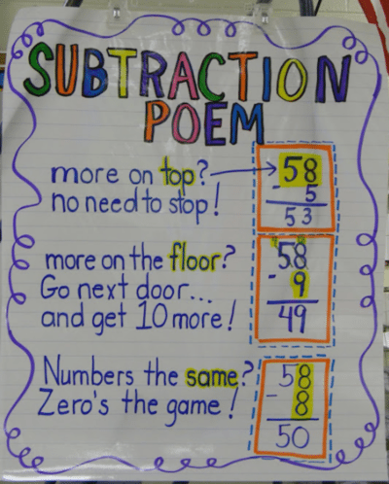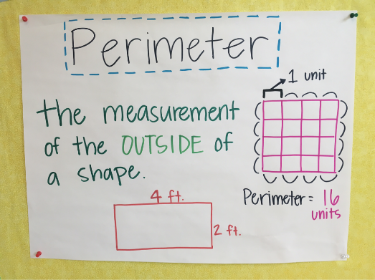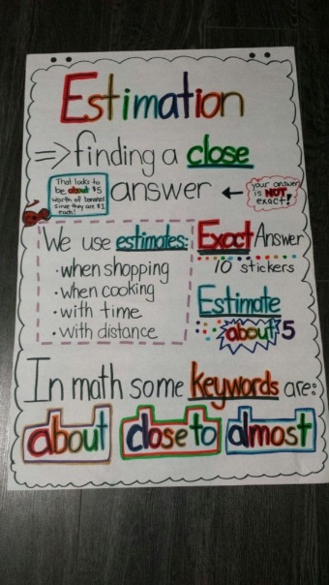

What we are learning…

Tests/Projects

-Unit 1 math test 9/1

-Timed Test 9/2

- Place Value Quiz 9/3