Setting Preferences to Receive Email Notifications

Log-in to Frontline and choose Professional Growth module
Go to My Info – My User Profile
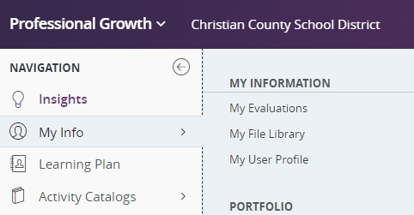

In order to receive email notifications regarding approvals or new activities, please mark YES in the PLM Email Notification Preferences section.
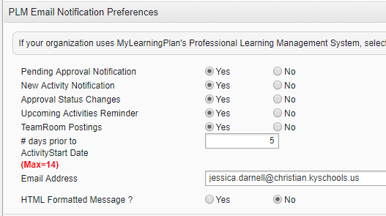
Scroll to the bottom and Click SAVE
