November 16 Lesson
RL 5.6 Objective: Describe how a narrator’s or speaker’s point of view influences how events are described.

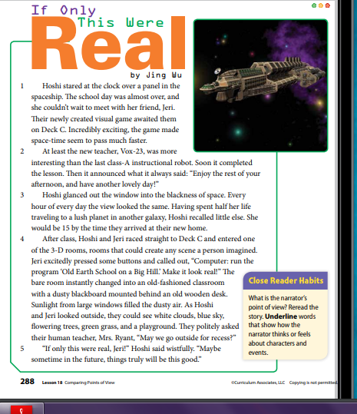

RL 5.6 #38
1. After reading the story, what do you know about the last instructional robot? (RL 5.6 #38)
A. Suggest it is boring.
B. Suggest it is interesting.
C. Suggest it is fun.
D. Suggest it is lazy.
2. After reading the story, what do you know about the new teacher Vox- 23? (RL 5.6 #38)
A. Suggest the teacher is a human.
B. Suggest the teacher is a instructional robot.
C. Suggest the teacher is boring.
D. Suggest the teacher is interesting.

3. After reading the story, what do you know about Hoshi? (RL 5.6 #38)
A. Suggest she wishes the 3D room was real.
B. Suggest she hates the 3D room.
C. Suggest she hates schools.
D. Suggest she hates Jeri.

4. After reading the story, what do you know about Jeri? (RL 5.6 #38)
A. Suggest Jeri hates school.
B. Suggest Jeri hates Hoshi.
C. Suggest Jeri is Hoshi’s Friend.
D. Suggest Jeri loves the 3D room.

5. After reading the story, what do you know about Mrs. Ryant? (RL 5.6 #38)
A. Suggest she is a robot.
B. Suggest she is the human teacher.
C. Suggest she hates school.
D. Suggest she hates science.

November 17 Lesson
RL 5.6 Objective: Describe how a narrator’s or speaker’s point of view influences how events are described.

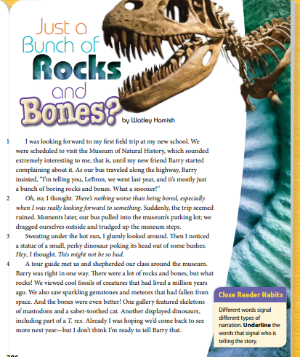

I Do We Do You Do Activity
RL 5.6 #38
I Do
After reading the story what do you know about Barry? (RL 5.6 #38)
A. Barry is excited about the field trip.
B. Barry thinks the field trip will be boring.
C. Barry has been on this field trip before and thinks it will be boring like the last time.
D. Barry is not excited about the field trip.

We Do
After reading the story what do you know about Lebron? (RL 5.6 #38)
A. Lebron is excited about the field trip.
B. Lebron thinks the field trip will be boring.
C. Lebron is not excited about the field trip.
D. Lebron is excited about the field trip, enjoyed the field trip, and is hoping to come back next year.

You Do
After reading the story what do you know about the tour guide? (RL 5.6 #38)
A. The tour guide is doing his or her job.
B. The tour guide hates children.
C. The tour guide is mad.
D. The tour guide is mean.

November 18 Lesson
RL 5.6 Objective: Describe how a narrator’s or speaker’s point of view influences how events are described.
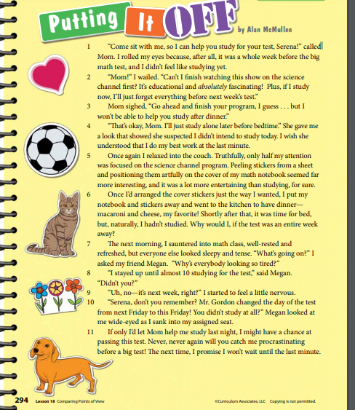

RL 5.6 #37
1. How does the speaker (Selena) point of view affect the way events are described in the story? (RL 5.6 #37)
A. The speaker thinks she has time to study for the test.
B. The speaker thinks she needs to study tonight.
C. The speaker thinks her mom is right.
D. The speaker doesn’t like to procrastinate.
2. How does the speaker (Mom) point of view affect the way events are described in the story? (RL 5.6 #37)
A. The speaker thinks Selena needs to study tonight.
B. The speaker thinks Selena should wait to study.
C. The speaker doesn’t care if Selena studies.
D. The speaker is busy making dinner and doesn’t have time to help Selena study.
3. How does the speaker (Megan) point of view affect the way events are described in the story? (RL 5.6 #37)
A. The speaker thinks Selena should have studied.
B. The speaker thinks Selena should have procrastinated.
C. The speaker thinks Selena should have continued to watch the science channel.
D. The speaker thinks Selena should have continued to peel stickers and put them on her math notebook.

November 19 Lesson
RL 5.6 Objective: Describe how a narrator’s or speaker’s point of view influences how events are described.

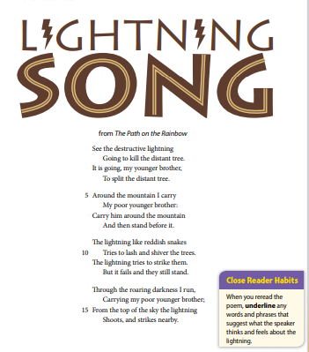

I Do We Do You Do Activity
RL 5.6 #37
I Do
1. How does the speaker’s point of view affect the way events are described in the poem?
(RL 5.6 #37)
A. The speaker thinks that the lightning is scary and somewhat powerful.
B. The speaker thinks that the lightning is not scary.
C. The speaker thinks that the lightning is not powerful.
D. The speaker thinks that the lightning is not going to cause harm to the trees.

We Do
1. How does the younger brother’s point of view affect the way events are described in the poem? (RL 5.6 #37)
A. The younger brother thinks that the lighting is scary.
B. The younger brother thinks that the lightning is playing.
C. The younger brother thinks that the lightning will defeat him.
D. The younger brother thinks that the lightning is funny.

You Do
1. How does the older sister/brother point of view affect the way events are described in the poem? (RL 5.6 #38)
A. The older sister/brother thinks that the lightning is not scary.
B. The older sister/brother thinks that the lightning is not powerful.
C. The older sister/brother thinks that the lightning is not going to cause harm to the trees.
D. The older sister/brother thinks that the lightning is scary and somewhat powerful.

The objective that will be on the weekly test on Friday November 20, 2020 will be RL 5.6 Objective: Describe how a narrator’s or speaker’s point of view influences how events are described.
Study the lessons above for the weekly test on Friday November 20, 2020. There will be five questions and a story to read.

