ANTI-VAPING CODE

The Cook County School District is committed to the health, safety, and welfare of its students. The District has determined that the use of vapes, vaporizers, e-cigarettes, or other devices used to inhale vapor by means of an electronic device (“vaping”) is harmful to the health of students and the good order of the School District. Vaping requires the use of a purpose-made or homemade device that vaporizes oil that may contain flavoring, nicotine, Cannabidiol (“CBD”) oil of varying concentrations, tetrahydrocannabinol (“THC”) oil of varying concentrations, or other substances that may or may not be legal to possess (“vape”). A vaping device is generally composed of a vaporizer, battery, reservoir for smoking oil, and a battery charger. By way of example and not as a limitation, vaping devices may be called vapes, Juuls, e-cigarettes, e-cigs, dab pens or other brand names.

It will be a violation of the Cook County Discipline Code to possess, use or transfer a vape as provided below.

For purposes of this section, the following definitions will apply:

- Cannabis. Tetrahydrocannabinol (THC) and cannabidiol (CBD) are the two primary cannabinoids that occur naturally in the cannabis sativa plant.

- CBD Oil. CBD oil is derived from a cannabis plant called hemp. Hemp contains a very high concentration of CBD and less than .3% by volume of THC.

- Low-THC Oil. Low-THC oil is derived from the cannabis plant that produces marijuana. Low-THC oil contains no more than 5% by volume of THC and may only be possessed or used under a doctor’s supervision with a prescription. Possession of Low-THC oil without a valid prescription is a felony.

- THC Oil. THC oil is derived from the cannabis plant and contains more than 5% by volume of THC. Some THC oil may contain up to 98% by volume of THC (3 - 5 times stronger than typical marijuana). Possession of THC oil is a felony.

- Vape. A vape is a purpose-made or homemade device that electronically vaporizes liquid to allow a user to inhale the vapor created in the lungs (i.e. vapes, juuls, e-cigarette, e-cig, dab
pen, vape sticks, etc.) Vape will include individually or together vape battery(ies), reservoir(s), vaporizer(s), and/or vape charger(s).

- Vape Juice. Vape juice is a slang term for the liquid used by the vaporizer to create vapor. Vape juice may contain flavored juice, CBD oil, Low THC oil or THC oil.

At present, there is no proven technology to quickly, easily and accurately test vape juice to identify its composition as flavored juice, nicotine juice, CBD oil, Low-THC oil or THC oil. Because of the documented, extreme health effects associated with high concentration THC oil this code creates a rebuttable presumption that vapes and vape juice contain THC oil. Absent clear and convincing evidence to the contrary the possession and/or use of vape juice will be treated as a Level 5 violation of this code.

.1 THE USE, ATTEMPT TO POSSESS, OR THE POSSESSION INDIVIDUALLY OR IN CONNECTION WITH OTHERS OF VAPE JUICE CONTAINING NICOTINE OR CBD OIL IN OR OUT OF A VAPE.

Disposition:

- Circumstances will determine which one or more of the following alternatives will be considered:

o Counseling with student, parents, and
o Use 5 Days OSS
- Attempt to Possess 3 Day Oss
- Possession Individually 5 Days Oss

- Connection with others 3 Days OSS

- If the offense occurs on a bus or at a bus stop, in addition to the school disposition, the student may be suspended from bus transportation, 10 school days.

REPORTING None

.2 THE USE, ATTEMPT TO POSSESS, OR THE POSSESSION INDIVIDUALLY OR IN CONNECTION WITH OTHERS OF VAPE JUICE CONTAINING NICOTINE OR CBD OIL IN OR OUT OF A VAPE. THE SECOND OR SUBSEQUENT USE, OR ATTEMPT TO POSSESS OR POSSESSION OF A VAPE IN ANY GIVEN SCHOOL YEAR.

Disposition:

- An immediate external suspension for Ten days from school; and because of serious nature of the infraction, a Tribunal may be scheduled with a recommendation for long-term assignment to alternative school or expulsion.

- If the offense occurs on a bus or at a bus stop, in addition to the school disposition, the student may be suspended from bus transportation Remainder of school year but no less than 90 days.

REPORTING None

.3 THE USE, ATTEMPT TO POSSESS, OR THE POSSESSION INDIVIDUALLY OR IN CONNECTION WITH OTHERS OR THE DISTRIBUTION OF VAPE JUICE CONTAINING LOW-THC OIL OR THC OIL IN OR OUT OF A VAPE.

Disposition:

- An immediate external suspension for Ten days from school; and because of the serious nature of the infraction, a Tribunal will be scheduled with a recommendation for long-term assignment to alternative school or expulsion.

- If the offense occurs on a bus or at a bus stop, in addition to the school disposition, the student will be suspended from bus transportation 1 school calendar year from date of incident.

- Distribution a recommendation for a multi-year expulsion.

- REPORTING CCSD Police

Message to Parents: Vaping Policy

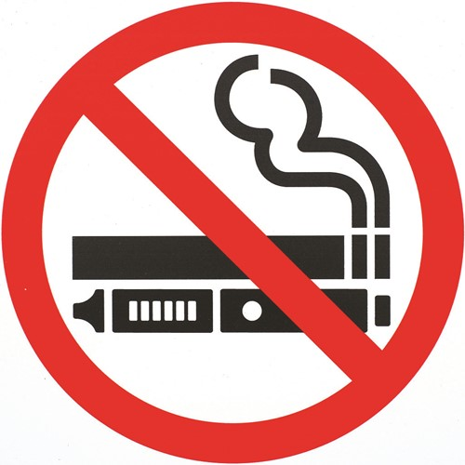
Dear Parents:
While CCSD’s student discipline code already prohibits the possession or use of vaping devices and oils anywhere on campus, this new policy adds more serious repercussions.
There has been a rising number of students not only using these devices at school to inhale nicotine, but also marijuana-based CBD and THC oil and other oils with dangerous contents that often are unknown to the student due to lack of regulation of these products. Students are becoming ill, overdosing, having seizures, passing out and requiring 911 response and hospitalization due to vaping. Students are encouraging classmates to try their devices at school and are using devices in shared spaces such as restrooms… further expanding the number of students negatively impacted by vaping.
Any students found with vaping devices or oil will be treated as if they are in possession of felony-level marijuana CBD and THC oil. Punishments will include immediate external suspension from school, long-term reassignment to an alternative school and possible expulsion.
Students must prove that their devices and oils do not contain marijuana-derived CBD and THC oil in order to avoid the most serious punishments, but even if that is proved, students still will face discipline for possessing nicotine-based or other vaping products (if you are not aware, these products are not legal for children younger than 18 to purchase or possess anywhere in Georgia).
We agree there are many other negative issues that impact students, from bullying to academic stress to economic struggles, and all of those are a priority and addressed through different policies and practices. Vaping is a new and serious threat to our students that is not yet on the radar of all parents. We need you to join us in helping protect the health of students by talking with your children about the dangers of vaping.
Information about this discipline code policy is being shared with all middle and high school students during school today by their Principal, and that message is online here. The U.S. Surgeon General website lists tips on how to talk with your child about vaping. If your child already is vaping and may be addicted to nicotine or THC, please seek assistance for them. For free help, visit smokefree.gov or call 1-800-QUIT-NOW.

