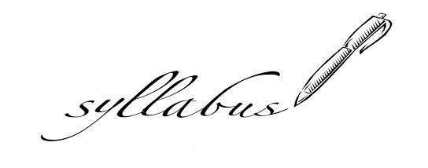
Contact Information:
email: ldyson@lanettcityschools.org
phone: 334-644-5985 (school) 256-738-1080 (cell)
website: https://lhs.lanettcityschools.org/lesliedyson

Course Description:
Students will continue to improve their playing ability on their primary instrument and learn a secondary instrument upon director supervision. Students are introduced to a wide variety of styles of music such as marches, sonatas, cannons, and chorales. Students learn characteristics about each style and correct musicality for playing in each style. Students also begin learning their major scales and arpeggios, the upper register/range of their instruments, alternate fingerings, and advanced playing techniques.
Course Objectives:
*Perform all 12 major scales and arpeggios.
*Demonstrate proper playing technique.
*Proficiently read and understand written music and terminology.

Classroom Expectations:
*Have your materials, instrument, music, and accessories (reed, mallets, valve oil, etc…) everyday
*Participate
*Be kind to each other...we don’t know what the other person’s going through.
*Follow directions…I aim to treat you as young adults if you will allow it

Consequences:
*Verbal Warning
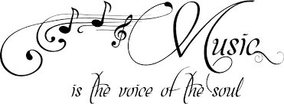
*Writing Assignment
*Parental Contact
*Referral
