Name___________________________Date___________________Per________

Half Life Simulation Lab

Discussion: Many people have heard the term "half-life" and know that it is related to radioactive elements. Half-life is defined as; "The time required for half of any given amount of a radioactive substance (Parent Atoms) to decay into another substance (Daughter Atoms)". Radioactive decay is a constant process where the unstable radioactive element breaks down to become a more stable element by releasing radioactive particles and radiation.

*This lab is written for using M&M’s as the parent atom but you can use any item that has two sides: Skittles, pennies, puzzle pieces, etc. The daughter atoms are represented by paperclips, but you can use any other item like beads, beans, etc.

Background Information: Testing of radioactive minerals in rocks best determines the absolute age of the rock.

In radiometric dating, different isotopes of elements are used depending on the predicted age of the igneous rocks. Potassium/Argon dating is good for rocks 100,000 years old since Potassium 40 has a half-life of 1.3 billion years! Uranium/Lead dating is used for the most ancient rock, since U-238 has a half-life of 4.47 billion years.
By comparing the percentage of an original element (parent atom) to the percentage of the decay element (daughter atom), the age of a rock can be calculated. The ratio of the two atom types is a direct function of its age because when the rock was formed, it had all parent atoms and no daughter atoms.
Procedure: Read the procedure before you start the lab

- Place the 50 candies in the cup. The atoms with the “M” side up are the number radioactive unstable “undecayed” Candium atoms (the parent atoms) in your igneous rock when it was formed
- Shake the cup- not too vigorously! Shake the cup for about 7.13 seconds (this represents 713 million years passing). This represents time to decay or one half-life.

- Carefully pour the Candium atoms onto a paper towel. Remove all the stable Candium atoms-those with the "M" side down. Replace in the cup these removed stable Candium atoms (parent atoms) with same number of stable atoms (daughter atoms). Use paperclips, beads, beans, or something similar to represent the daughter atoms.

The total number of M&M's and paperclips in your cup must be the same as the number of M&M's you started with (50). Atoms are never lost they just decay from the radioactive atoms (M&Ms) to more stable ones (flipped over M&Ms or paperclips).

- Count and record the number of radioactive “undecayed” Candium atoms (‘M’ side up) remaining. Record in the data table.

- Repeat steps 2, 3 and 4 until all the candies “decayed” (flipped ‘M’ side down) or 10 shakes of the cup-which ever happens first.

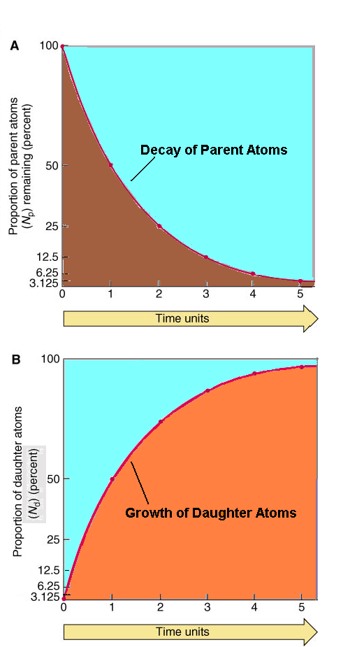
Data Table

Time  (# of shakes)  Half Lives | Number of “undecayed”  radioactive Candium atoms  remaining with the “M” side up. “Parent” atoms. | Number of Greenium atoms. The stable “daughter” atoms.
0 | 50 | 0
1
2
3
4
5
6
7
8
9
10

Data Analysis

Please use the graph below plot your data of parent and daughter atoms over time passed (millions of years).
Questions

- The M&M's represent the ______________________.

- The paperclips represent the _______________________ .

- How much of a radioactive element becomes stable in a half-life?

- If you started with 100 M&M's, would the half-life change? Please explain.

