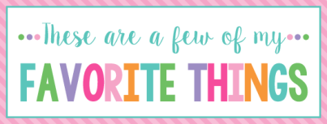

Name:___Janet Williams_________ T Shirt Size:___2x__________
Birthday:_8/28/70 ______________ Monogram:____JWE_________
Favorite Color:_purple and teal__ Favorite Flower:__Wildflowers__
Favorite Scent:_troical or apple cinnamon Favorite Candy: none
Favorite Drink:VIBE tea, water, tea w/splenda Favorite Food:_salad/ pizza___ Favorite Snack: mixed nuts, Slimfast Keto bombs Favorite Fruit:strawberries
Favorite Restaurant: Newk’s, Buon Cibo, Pyro’s Pizza________
Favorite Fast Food:_Zaxby’s, Sonic, Arby’s, Subway___________
Favorite Places to Shop:_Amazon, Hobby Lobby, Michael’s Walmart, Target
Favorite Bath & Body Works Scent: tropical___________
Things I collect: unique salt n pepper shakers, and elephants________
Favorite Author /Book Series for my own personal reading:__suspense, thrillers or mysteries__________________
Wish List for Classroom:_small prizes for treasure box, individually wrapped candy, pens, erasable pens, color copy paper, colored and white card stock, first aid ointment, and Mr. Stetch markers

** Please turn in to Mrs. Still by Friday.***

