Brimfield Grade School - 1st Grade Supply List

All supplies should be marked with your child’s name or initials. Please label each crayon, marker, pencil, eraser, glue stick, etc.
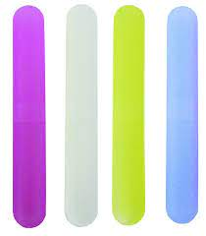
- 1 box of 24 count Crayola Crayons
- 1 box of Classic Colors Washable Crayola Markers
- 1 package of 24, #2 pencils, Ticonderoga Brand
- 2 travel toothbrush cases (like image here - to hold pencils inside desks)
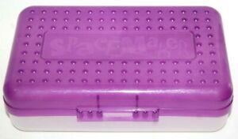
- 8 Elmer’s Glue Sticks
- 2 Pink Pearl Erasers
- 2 - 5x8 Plastic Pencil Boxes or 2 - 5x8 (or so) clear makeup bags that zip
- 1 pocket folder for desk - plastic style only with pockets, no clasps
- 1 set FINE tip Expo dry erase markers
- 1 container Clorox Wipes
- 1 hand pump sanitizer container (12 oz or smaller bottle)
- 1 box Kleenex
- PE shoes VELCRO only - clean to stay at school
- Headphones in a labeled gallon baggie - no ear buds please
- 1 pair child pointed scissors
- 1 Backpack - no rolling/wheeled backpacks
- 1 sock or 1 dry erase eraser for use with dry erase boards

PTO will supply a red communication folder for their backpack to send home homework, etc.
*There may be a request to replenish any supplies needed for your child.

Donations needed: baby wipes, paper plates, paper towels, 2.5 Gallon sized bags, Gallon sized bags, Quart sized bags, Sandwich sized bags & stickers.

