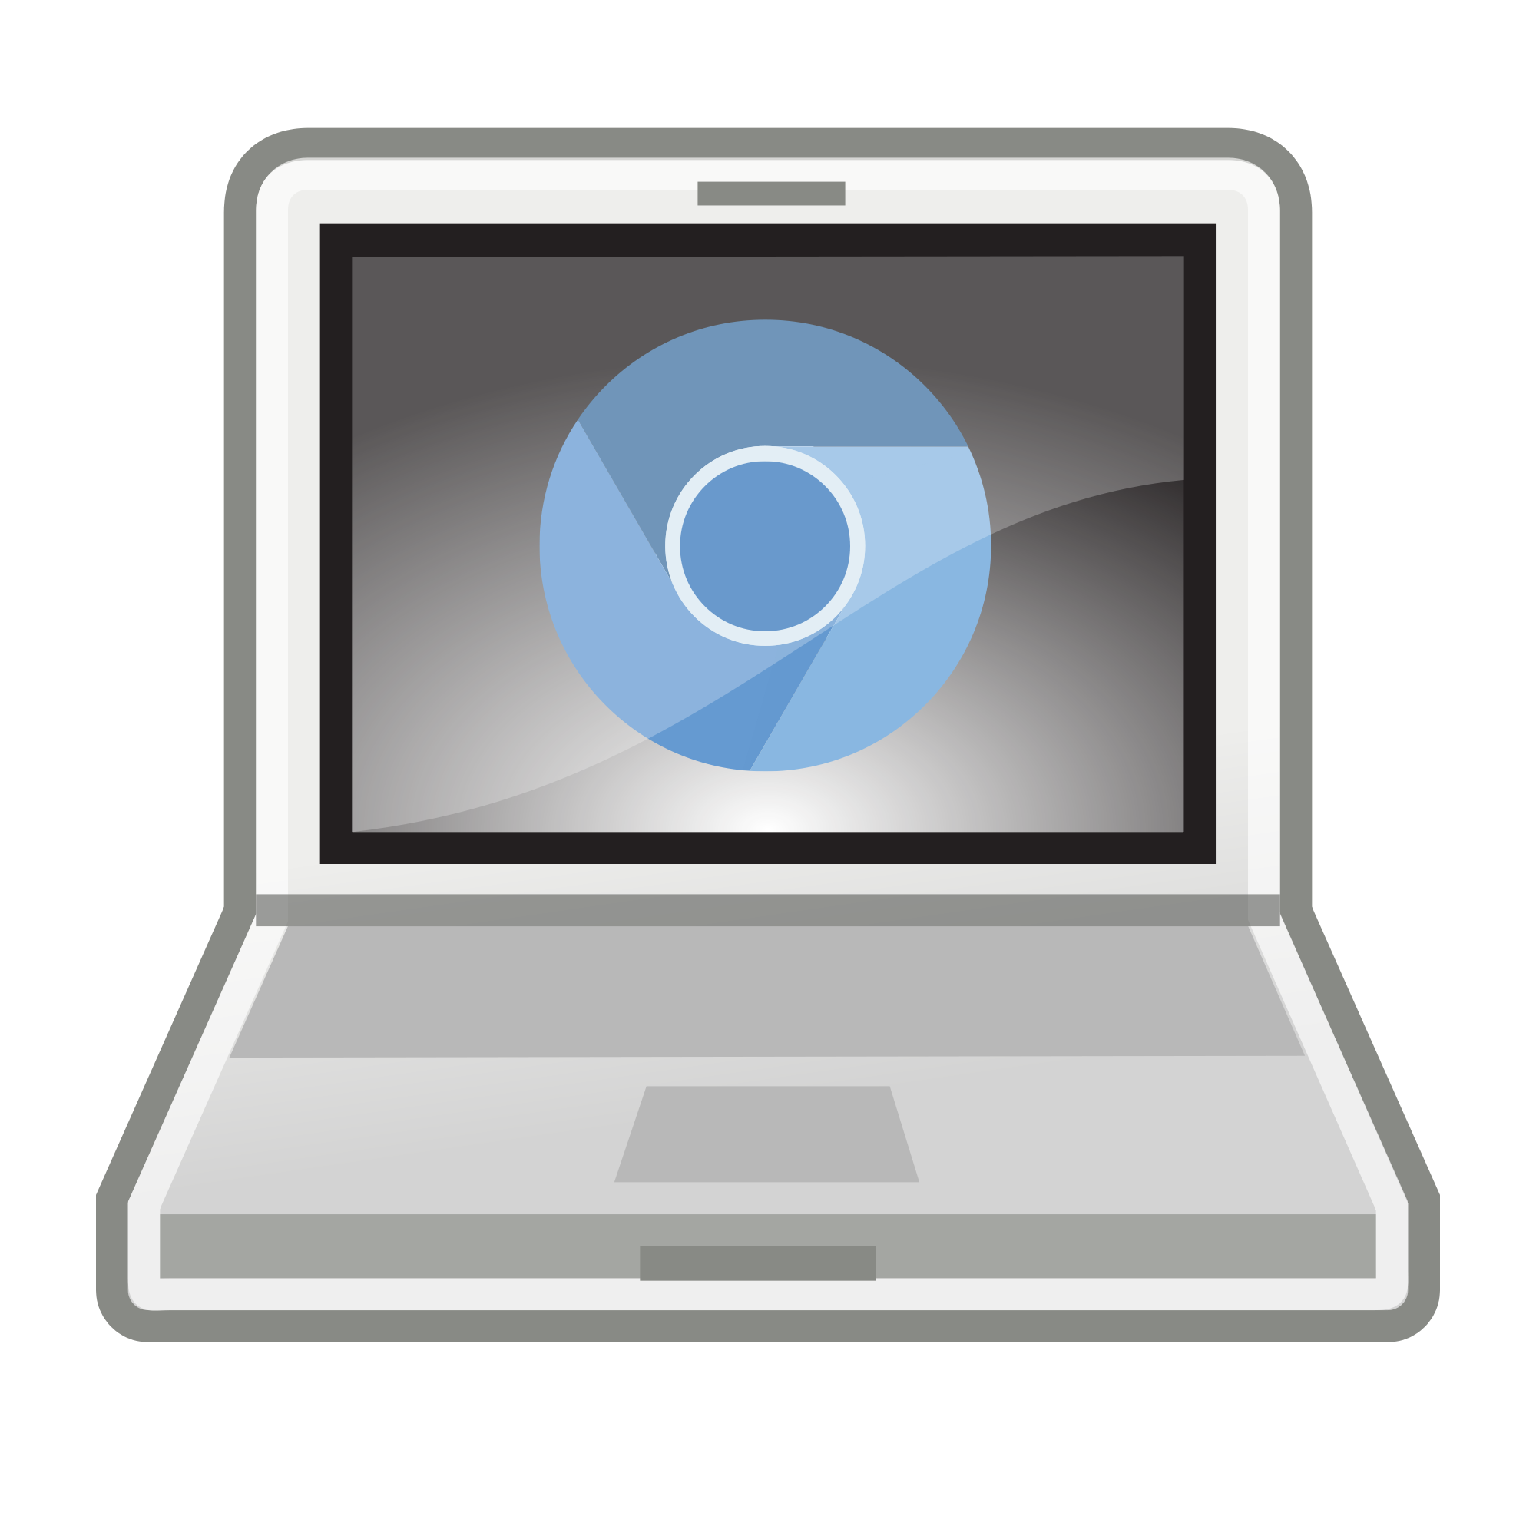

Tech Tip - Canvas

CANVAS - What’s it all about?
The CANVAS Learning Management System (LMS), implemented this fall, will support instruction and student learning in a variety of circumstances, including in-person instruction, remote learning, or a hybrid model of in-person and distance learning as required.
This user-friendly learning management system will help ensure access to high-quality instruction across a variety of settings. It also enhances collaboration and the sharing of resources both within schools and across the district and state.
The LMS integrates with other resources and systems so that teachers can create rich learning experiences for students, leveraging both resources that they have used successfully in past classes and integrating new materials into classes.
Using a consistent LMS across all classes and grade levels PreK-Graduation is a student-centered, family-centered, and staff-centered practice that will support our students’ learning.
Some features include:
Allow teachers to set prerequisite assignments that must be completed before a student can move forward to the next lesson or activity.
Provide accommodations and modifications for all users as well as opportunities to provide student specific feedback, and create personalized learning paths.
Provide analytics that let teachers and administrators know how the system is being used and by whom and monitor student progress.
Integrate with Google Suite and MMS.
Are customizable so that teachers can set up developmentally appropriate interfaces that serve a range of learners.
Curate and share instructional resources within and across schools;
Provide greater clarity regarding assignment due dates for students and families;
Create a consistent user dashboard across the district;
Embed videos directly into the platform;
Integrate with other resources that were widely and successfully used last spring such as Google Classroom; and
Support users throughout their experience by offering professional development opportunities and robust technical support.

Professional Development Resources:
Intro to Canvas Slides - Oct. 9, 2020

Self-Paced Canvas Course
Sign up for a self-paced Canvas course to learn more about using Canvas in your teaching.
- Go to https://www.canvas.net/browse/cn-pd/courses/growing-with-canvas
- Scroll to the bottom of the page
- Select the ENROLL button to register for the course

